Prediction from Weeks to Decades

Ben Kirtman, David Anderson, Gilbert Brunet, In-Sik Kang, Adam Scaife and Doug Smith

Abstract

This white paper is a synthesis of several recent workshops, reports and published literature on monthly to decadal climate prediction: (Smith et al., 2012; Anderson et al. 2011; Weller et al. 2010; Meehl et al. 2009; Hurrell et al. 2009; Shukla et al. 2010 and Brunet et al. 2010). The intent is to document: (i) the scientific basis for prediction from weeks to decades; (ii) current capabilities; and (iii) outstanding challenges.

- Introduction

Numerical weather forecasts have seen profound improvements over the last 30-years with the potential now to provide useful forecasts beyond 10 days ahead, especially those based on ensemble, probabilistic systems. Despite this continued progress, it is well accepted that even with a perfect model and nearly perfect initial conditions, the fact that the atmosphere is chaotic causes forecasts to lose predictive information from initial conditions after a finite time (Lorenz 1965), in the absence of forcing from other parts of the Earth’s system such as ocean surface temperatures and land surface soil moisture. As a result, for many aspects of weather the “limit of predictability” is about two weeks.

So, why is climate prediction (i.e., forecast beyond the limit of weather predictability) possible? While there is a clear limit to our ability to forecast day-to-day weather, there exists a firm scientific basis for the prediction of time averaged climate anomalies. Climate anomalies result from complex interactions among all the components of the Earth system. The atmosphere, which fluctuates very rapidly on a day-to-day basis, interacts with the more slowly evolving components of the Earth system, which are capable of exerting a sustained influence on climate anomalies extending over a season or longer, far beyond the limit of atmospheric predictability from initial conditions alone. The atmosphere, for example, is particularly sensitive to tropical sea surface temperature anomalies such as those that occur in association with El Nino and the Southern Oscillation (ENSO). There is also increasing evidence that external forcings, such as solar variability, greenhouse gas and aerosol concentrations, land use and volcanic eruptions, also ‘lend’ predictability to the system, which can be exploited on sub-seasonal to decadal timescales.

Consequently, numerical models used for climate prediction have progressed from atmospheric models with a simple representation of the oceans to fully coupled Earth system models complete with fully coupled dynamical oceans, land surface, cryosphere and even chemical and biological processes. In fact, many operational centers around the world now produce sub-seasonal to seasonal predictions using observed initial conditions that include components of the Earth system beyond the atmosphere.

The traditional boundaries between weather forecasting and climate prediction are fast disappearing since progress made in one area can help to accelerate improvements in the other. For example, improvements in the modeling of soil moisture made in climate models can lead to improved weather forecasting of showers over land in summer; and data assimilation, which has been restricted to the realm of weather prediction, is now becoming a requirement of coupled models used for longer term predictions (Brunet et al, 2010).

As the scope of numerical weather forecasting and climate prediction broadens and overlaps, the fact that both involve modeling the same system becomes much more relevant, as many of the processes are common to all time scales. There is much benefit to be gained from a more integrated or “seamless” approach. Unifying modeling across all timescales should lead to efficiencies in model development and improvement by sharing and implementing lessons learned by the different communities. There are many examples of the benefits of this approach (e.g. Brown et al. 2012, BAMS in press). These include enabling climate models to benefit from what is learned from data assimilation in weather forecasting, enabling weather forecasting models to learn from the coupling with the oceans in climate models, and sharing the validation and benchmarking of key common processes such as tropical convection. The inclusion of atmospheric chemistry and aerosols, essential components of Earth system models used for projections of climate change, can now be exploited to improve air quality forecasting and the parametrization of cloud microphysics. Predictions of flood events require better representation of hydrological processes at local, regional, continental and global scales, which are important across all time scales. Diagnostic of precipitation model errors show often significant similarity between climate and weather prediction systems hence pointing out to a common solution to the problem. The use of a common core model for various applications is also an opportunity to save human time when porting a system to a new computational platform.

Clearly, there is a growing demand for environmental predictions that include a broad range of space and time scales and that include a complete representation of physical, chemical and biological processes. Meeting this demand could be accelerated through a unified approach that will challenge the traditional boundaries between weather and climate science in terms of the interactions of the bio-geophysical systems. It is also recognized that interactions across time and space scales are fundamental to the climate system itself (Randall et al. 2003; Hurrell et al. 2009; Shukla et al. 2008; Brunet et al. 2010). The large-scale climate, for instance, determines the environment for microscale (order 1 km) and mesoscale (order 10 km) variability which then feedback onto the large-scale climate. In the simplest terms, the statistics of microscale and mesoscale variability significantly impact the simulation of weather and climate and the feedbacks between all the biogeophysical systems. However, these interactions are extremely complex making it difficult to understand and predict the Earth system variability that we observe.

We also note that predictions can be made using purely statistical techniques, or dynamical models, or a combination of both. Statistical and dynamical methods are complementary: improved understanding gained through successful statistical forecasts may lead to better dynamical models, and vice versa. Furthermore, statistical methods provide a baseline level of skill that more complex dynamical models must aim to exceed. Statistical methods are actively used to correct model erros beyond the mean bias so that model output can be used by application models.

Increasingly all forecasts are probabilistic, reflecting the fact that the atmosphere and oceans are chaotic systems and that models do not fully capture all the scales of motion, i.e. the model itself is uncertain (see Slingo and Palmer 2011 for a full discussion of uncertainty). That being the case, skill cannot be judged based on a single case since a probabilistic prediction is neither right nor wrong. Instead an ensemble prediction system produces a range of possible outcomes, only one of which will be realized. Its skill can therefore only be assessed over a wide range of cases where it can be shown that the forecast probability matches the observed probability (e.g., Palmer et al. 2000; Goddard et al. 2001; Kirtman 2003; Palmer et al. 2004; DeWitt 2005; Hagedorn et al. 2005; Doblas-Reyes et al. 2005; Saha et al. 2006, Kirtman and Min 2009, Stockdale et al 2011, Arribas et al 2011 and others)

Given our current modeling capabilities, a multi-model ensemble strategy may be the best current approach for adequately resolving forecast uncertainty (Derome et al., 2001; Palmer et al. 2004; Hagedorn et al. 2005; Doblas-Reyes 2005; Palmer et al. 2008, Wang et al 2010). The use of multi-model ensembles can give a definite boost to the forecast reliability compared to that obtained by a single model (e.g., Hagedorn et al., 2005; Guilyardi, 2006; Jin et al., 2008; Kirtman and Min, 2009; Krishnamurti et al. 2010). Although a multi-model ensemble strategy represents the “best current approach” for estimating uncertainty, it does not remove the need to improve models and our understanding.

Another factor in climate prediction is that, unlike weather forecasting, model-specific biases grow strongly in a fully coupled ocean-atmosphere system, to the extent that the distribution of probable outcomes in seasonal to decadal forecasts may not reflect the observed distribution, and thus the forecasts may not be reliable. It is essential, therefore, that forecast reliability is assessed using large sets of model hindcasts. These enable the forecast probabilities to be calibrated based on past performance and the model bias to be corrected. However, these empirical correction methods are essentially linear and yet we know that the real system is highly nonlinear. As Turner et al. [2005] have demonstrated, there is inherently much more predictive skill if improvements in model formulation could be made that reduce these biases, rather than correcting them after the fact.

2. Sub-Seasonal Prediction

Forecasting the day-to-day weather is primarily an atmospheric initial condition problem, although there can be an influence from land and sea-ice (Pellerin et al., 2004; Smith et al., 2012) conditions and ocean temperatures. Forecasting at the seasonal-to-interannual range depends strongly on the slowly evolving components of the Earth system, such as the ocean surface, but all the components can influence the evolution of the system. In between these two time-scales is sub-seasonal variability.

2.1 Madden Julian Oscillation

Perhaps the best known source of predictability on sub-seasonal timescales is the Madden-Jullian Oscillation (MJO, Madden and Julian, 1971). This has a natural timescale in the range 30-70 days. It is associated with regions of enhanced or reduced precipitation, and propagates eastwards, with speeds of ~5m/s, depending on its longitude. The MJO clearly influences precipitation in the tropics. It influences tropical cyclone activity in the western and eastern north Pacific, the Gulf of Mexico, southern Indian Ocean and Australia (See Vitart 2009 for references). It also influences the Asian and Australian monsoon onset and breaks and is associated with northward moving events in the Bay of Bengal (Lawrence and Webster 2002). Recent estimates of the potential predictability associated with the MJO suggest that it may be as much as 40 days (Rashid et al. 2010).

Interaction with the ocean may play some role in the development and propagation of the MJO, but does not appear to be crucial to its existence (Woolnough et al 2007, Takaya et al 2010). The way convection is represented in numerical models does influence the characteristics of the MJO quite strongly, however. Until recently the MJO was quite poorly represented in most models. There are now some models that have something resembling an MJO (Pegion and Kirtman 2008; Vitart and Molteni 2010; Waliser et al 2009; Shi et al 2010; Wang et al 2010; Gottschalck et al 2010; Lin et al. 2010 and Lin and Brunet 2011) but more remains to be done.

Not only is the MJO important in the tropics, there is growing evidence that it has an important influence on northern hemisphere weather in the PNA (Pacific North American pattern) and even in the Atlantic and European sectors. Cassou (2008) and Lin et al. (2009) have studied the link from the MJO to modes of the northern hemisphere including the North Atlantic Oscillation. In Lin et al. (2009) time-lagged composites and probability analysis of the NAO index for different phases of the MJO reveal a statistically significant two-way relationship between the NAO and the tropical convection of the MJO (see Table 1). A significant increase of the NAO amplitude happens about one to two weeks after the MJO-related convection anomaly reaches the tropical Indian Ocean and western Pacific region. The development of the NAO is associated with a Rossby wave train in the upstream Pacific and North American region. In the Atlantic and African sector, there is an extratropical influence on the tropical intraseasonal variability. Certain phases of the MJO are preceded by two to four weeks by the occurrence of strong NAOs. A significant change of upper zonal wind in the tropical Atlantic is caused by a modulated transient westerly momentum flux convergence associated with the NAO.
The MJO has also been found to influence the extra-tropical weather in various locations. For example, Higgins et al. (2000) and Mo and Higgins (1998) investigated the relationships between tropical convection associated with the MJO and U.S. West Coast precipitation. Vecchi and Bond (2004) found that the phase of the MJO has a substantial systematic and spatially coherent effect on sub-seasonal variability in wintertime surface air temperature in the Arctic region. Wheeler et al. (2009) documented the MJO impact on Australian rainfall and circulation. Lin and Brunet (2009) and Lin et al. (2010b) found significant lag connection between the MJO and the intra-seasonal variability of temperature and precipitation in Canada. It is also observed that with a lead time of 2-3 weeks, the MJO forecast skill is significantly influenced by the NAO initial amplitude (Lin and Brunet 2011)

The importance of the tropics in extra-tropical weather forecasting has been illustrated by several authors. Early results from Ferranti et al (1990) indicated that better representation of the MJO led to better mid-latitude forecasts in the northern hemisphere, and the benefit of the connection of the MJO and NAO in intra-seasonal forecasting has been demonstrated in Lin et al. (2010a). With a lead time up to about one month the NAO forecast skill is significantly influenced by the existence of the MJO signal in the initial condition. A strong MJO leads to a better NAO forecast skill than a weak MJO. These results indicate that it is possible to increase the predictability of the NAO and the extra-tropical surface air temperature with an improved tropical initialization, a better prediction of the tropical MJO and a better representation of the tropical-extra-tropical interaction in dynamical models.

2.2 Other sources of sub-seasonal predictability

An important source of potential predictability comes from the relatively persistent variations in the lower stratosphere following sudden stratospheric warmings and other stratospheric flow changes, which have been shown to precede anomalous circulation conditions in the troposphere (Kuroda and Kodera, 1999; Baldwin and Dunkerton 2001). The long radiative timescale and wave-mean flow interactions in the stratosphere can lead to persistent anomalies in the polar circulation. These can then influence the troposphere, particularly in the mid-latitudes to produce persistent anomalies in the storm track regions and highly populated areas around the Atlantic and Pacific basins (Thompson and Wallace 2000). Once they occur, stratospheric sudden warmings provide further predictability during winter and spring, although the extent to which they are themselves predictable is generally limited to one to two weeks (Marshall and Scaife (2010a)).

Soil moisture memory spans intraseasonal time scales depending on the season. Memory in soil moisture is translated to the atmosphere through the impact of soil moisture on the surface energy budget, mainly through its impact on evaporation. Soil moisture initialization in forecast systems is known to affect the evolution of forecast precipitation and air temperature in certain areas during certain times of the year on intraseasonal time scales (e.g., Koster et al., 2010). Model studies (Fischer et al. 2007) suggest that the European heat wave of summer 2003 was exacerbated by dry soil moisture anomalies in the previous spring.

Hudson et al (2010a,b) and Hamilton et al. (2012) have shown that modes of climate variability, such as ENSO, the Indian Ocean Dipole (IOD) and the Southern Annular Mode (SAM), are sources of intra-seasonal predictability; if ENSO/IOD/SAM are in extreme phases, intra-seasonal prediction is extended. These studies argue that it is not predicting intra-seasonal variations in the tropics per se that matters, but that these slow variations shift the seasonal probabilities of daily weather one way or the other and this shift can be detected as short as 2 weeks into the forecast.

Although the field is still in its infancy, early results concerning the extent of polar predictability also show promise (e.g., Blanchard-Wrigglesworth et al. 2011). Most of these efforts have taken place in Europe or North America and have therefore focused on the Arctic and North Atlantic. Operational seasonal prediction systems for the Arctic show the impact of summertime sea-ice and fall Eurasian snow-cover anomalies, and September Arctic sea-ice extent appears to be predictable given knowledge of the springtime ice thickness or early to mid summer sea ice extent.

3. Seasonal-to-Interannual Prediction

In many respects seasonal prediction is the most mature of the three timescales under consideration in this paper. Statistical methods have been used for many decades, especially for the Indian Summer Monsoon, and the seasonal timescale has been the primary focus of the early development of ensemble prediction systems. The seasonal timescale is also one in which the low frequency forcing from the ocean, especially El Nino/La Nina, really begins to dominate and provide significant levels of predictability.

3.1 El Nino Southern Oscillation (ENSO)

The largest source of seasonal-to-interannual prediction is ENSO. ENSO is a coupled mode of variability of the tropical Pacific that grows through positive feedbacks between sea surface temperature (SST) and winds - a weakening of the easterly trade winds produces a positive SST anomaly in the eastern tropical Pacific which in turn alters the atmospheric zonal (Walker) circulation to further reduce the easterly winds. The time between El Niño events is typically about 2 to 7 years, but the mechanisms controlling the reversal to the opposite La Niña phase are not understood completely, nor are those that lead to sustained La Nina events extending beyond one year.

ENSO influences seasonal climate almost everywhere (see Fig. 2 taken from Smith et al. 2012), either by directly altering the tropical Walker circulation (Walker and Bliss 1932), or through Rossby wave trains that propagate to mid and high latitudes (Hoskins and Karoly 1981), substantially modifying weather patterns over North America. There is also a notable influence on the North Atlantic Oscillation (NAO), especially in late winter (Brönimann et al. 2007). It has also been shown that ENSO governs much of the year-to-year variability of global mean temperature (Scaife et al 2008). However, the strongest impacts of ENSO occur in Indonesia, North and South America, East and South Africa, India and Australia. A notable recent example was the intense rainfall and flooding in Northeast Australia during 2010/11 during a pronounced La Nina event – the strongest since 1973/4.

The ability to predict the seasonal variations of the tropical climate dramatically improved from the early 1980s to the late 1990s. This period was bracketed by two of the largest El Niño events on record: the 1982-83 event and the 1997-98 event. In the case of the former, there was considerable confusion as to what was happening in the tropical Pacific (see Anderson 2011). As a result the NOAA Tropical Atmosphere Ocean (TAO) array of tethered buoys was implemented across the equatorial Pacific, providing essential observations of the ocean’s sub-surface behavior. By contrast the development of the 1997-8 El Nino was monitored very carefully and considerably better forecast. This improvement was due to the convergence of many factors. These included: (i) a concerted international programme, called TOGA (Tropical Oceans Global Atmosphere), with the remit to observe, understand and predict tropical climate variability; (ii) the application of theoretical understanding of coupled ocean-atmosphere dynamics, and (iii) the development and application of models that simulate the observed variability with some fidelity. The improvement led to considerable optimism regarding our ability to predict seasonal climate variations in general and El Niño/Southern Oscillation (ENSO) events in particular.

Despite these successes, basic questions regarding our ability to model the physical processes in the tropical Pacific remain open challenges in the forecast community. For instance, it is unclear how the MJO, Westerly Wind Bursts (WWBs), intra-seasonal variability or atmospheric weather noise influence the predictability of ENSO (e.g., Thompson and Battisti, 2001; Kleeman et al., 2003; Flugel et al., 2004; Kirtman et al., 2005) or how to represent these processes in current models. It has been suggested that enhanced MJO and WWB activity was related to the rapid onset and the large amplitude of the 1997-98 event (e.g., Slingo et al. 1998; Vecchi and Harrison, 2000; Eisenman et al., 2005). However, more research is needed to fully understand the scale interactions between ENSO and the MJO and the degree that MJO/WWB representation is needed in ENSO prediction models to better resolve the range of possibilities for the evolution of ENSO (Lengaigne et al. 2006; Wittenberg et al., 2006).

After the late 1990s, however, the ability of some models to predict tropical climate fluctuations reached a plateau with only modest subsequent improvement in skill; but see for example Stockdale et al. (2011) who document progress with one coupled system over more than a decade of development. Arguably, there were substantial qualitative forecasting successes - almost all the models predicted a warm event during the boreal winter of 1997/98, one to two seasons in advance. Despite these successes, there have also been some striking quantitative failures. For example, according to Barnston et al. (1999) and Landsea and Knaff (2000) none of the models predicted the early onset or the amplitude of that event, and many of the dynamical forecast systems (i.e., coupled ocean-atmosphere models) had difficulty capturing the demise of the warm event and the development of cold anomalies that persisted through 2001. In subsequent forecasts, many models failed to predict the three consecutive years (1999–2001) of relatively cold conditions and the development of warm anomalies in the central Pacific during the boreal summer of 2002. Accurate forecasts can still sometimes be a challenge even at relatively modest lead-times (Barnston 2007; personal communication) although the recent 2009/10 El Nino and 2010/11, 2011/12 La Nina events were well predicted at least 6 months in advance by most operational centers.

Typically, prediction systems do not adequately capture the differences between different ENSO events such as the recently identified different types of ENSO event (Ashok et al., 2007). In essence, the prediction systems do not have a sufficient number of degrees of freedom for ENSO as compared to nature. There are also apparent decadal variations in ENSO forecast quality (Balmaseda et al., 1995; Ji et al., 1996; Kirtman and Schopf, 1998), and the sources of these variations are the subject of some debate. It is unclear whether these variations are just sampling issues or are due to some lower frequency changes in the background state (see Kirtman et al. 2005 for a detailed discussion).

Chronic biases in the mean state of climate models and their intrinsic ENSO modes remain, and it is suspected that these biases have a deleterious effect on El Nino/La Nina forecast quality and the associated teleconnections. Some of these errors are extremely well known throughout the coupled modeling community. Three classic examples, which are likely interdependent, are 1) the so-called double ITCZ problem, 2) the excessively strong equatorial cold tongue typical to most models, and 3) the sub-tropical eastern Pacific and Atlantic warm biases endemic to all models. Such biases may limit our ability to predict seasonal-to-interannual climate fluctuations, and could be indicative of errors in the model formulations. Resolution may be one cause of some of these errors (e.g. Luo et al 2005). Studies with models that employ higher resolution in both the atmosphere and ocean have demonstrated significant improvements in the mean state of the tropical Pacific and the simulation of El Nino and its teleconnections (e.g. Shaffrey et al. 2009).

3.2 Tropical Atlantic Variability

On seasonal-to-interannual time scales, tropical Atlantic SST variability is typically separated into two patterns of variability - the gradient pattern and the equatorial pattern (Kushnir et al. 2006). The gradient pattern is characterized as a north-south dipole centered at the equator with the largest signals in the sub-tropics, and is typically associated with variability in the southern-most position of the inter-tropical convergence zone (ITCZ). The equatorial pattern is sometimes referred to as the zonal mode (e.g., Chang et al. 2006), or the “Atlantic Nino” because of its structural similarities to the ENSO pattern in the Pacific, although the phase locking with the annual cycle is quite different and the air-sea feedbacks are weaker leading to a more clearly damped mode of variability (e.g., Nobre et al. 2003).

The gradient pattern is linked to large rainfall variability over South America and the northeast region (Nordeste) of Brazil in particular during the boreal spring (Moura and Shukla 1981; Nobre and Shukla 1996). The positive gradient pattern (i.e., warm SSTA to the north of the equator) is associated with a failure of the ITCZ to shift its southern most location during boreal spring. This leads to large-scale drought in much of Brazil and coastal equatorial Africa. The equatorial pattern in the positive phase is linked to increased maritime rainfall just south of the climatological position of the boreal summer ITCZ. The associated terrestrial rainfall anomalies are typically relatively small.

Early predictability studies (Penland and Matrosova 1998) suggest that the north tropical Atlantic component of the gradient pattern (and variability in the Caribbean) can be predicted one to two seasons in advance largely due to the “disruptive” or excitation influence from the Indo-Pacific SSTA, but this does not suggest that local coupled processes in the region are unimportant (e.g., Nobre et al. 2003). The NAO can also be an external excitation mechanism, but again local processes remain important for the life cycle of the variability. The predictability of the southern sub-tropical Atlantic component of the gradient mode has not been well established, and is largely viewed as independent from ENSO (Huang et al. 2002). There has been little success in predicting the zonal mode.

3.3 Tropical Indian Ocean Variability

There are three dominant patterns of variability in the tropical Indian Ocean that affect remote seasonal-to-interannual rainfall variability over land: (i) a basin- wide pattern that is remotely forced by ENSO (e.g., Krishnamurthy and Kirtman 2003); (ii) the so-called Indian Ocean Dipole/Zonal Mode (IOD for simplicity) that can be excited by ENSO, but also can also develop independently of ENSO (e.g., Saji et al. 1999; Webster et al. 1999; Huang and Kinter 2002); and (iii) a gradient pattern similar to the Atlantic that is prevalent during boreal spring (Wu et al. 2008). The basin wide pattern is slave to ENSO and thus its predictability is largely determined by the predictability of ENSO. The IOD plays an important role in the Indian Ocean sector response to ENSO and contributes to regional rainfall anomalies that are independent of ENSO. Idealized predictability studies suggest that the IOD should be predictable up to about 6-months (Wajsowicz 2007; Zhao and Hendon 2009), but prediction experiments are less optimistic (e.g., Zhao and Hendon 2009). Shi et al 2012 compare the skill of several operational seasonal forecast models, and consider whether larger amplitude events are more skillfully predicted. The predictability of the Indian Ocean meridional mode has not been investigated to date.

Mechanistically, the basin wide mode is captured in thermodynamic slab mixed layer models suggesting that ocean dynamics is of secondary importance and that the pattern is due to an “atmospheric bridge” associated with ENSO (e.g., Lau and Nath 1996; Klein et al. 1999). The IOD, on the other hand, depends on coupled air-sea interactions and ocean dynamics. For example, Saji et al. (1999) noted that the IOD was associated with east-west shifts in rainfall and substantial wind anomalies. Huang and Kinter (2002) argued for well defined (although not as well defined as for ENSO) interannual oscillations where thermocline variations due to asymmetric equatorial Rossby waves play an integral role in the evolution of the IOD. The importance of thermocline variations are a potential source of ocean memory and hence predictability. The development and decay of the meridional mode is largely driven by local thermodynamic cloud and wind feedbacks induced by either ENSO or the IOD, whereas thermocline variations do not seem to be important (Wu et al. 2008).

3.4 Other sources of seasonal to interannual predictability

3.4.1 Upper ocean heat content

On seasonal-to-interannual time scales upper ocean heat content is a known source of predictability. The ocean can store a tremendous amount of heat. The heat capacity of 1 m³ of seawater is around 3,500 times that of air. Sunlight penetrates the upper ocean, and much of the energy associated with sunlight can be absorbed directly by the top few meters of the ocean. Mixing processes further distribute heat through the surface mixed layer, which can be tens to hundreds of meters thick. With the difference in heat capacity, the energy required to cool the upper 2.5 m of the ocean by 1ºC could heat the entire column of air above it by the same 1ºC. The ocean can also transport warm water from one location to another, so that warm tropical water is carried by the Gulf Stream off New England, where in winter during a cold-air outbreak, the ocean can heat the atmosphere at a rate of many hundreds of W/m2, similar to the heating rate from solar irradiation.

Ocean heat can also be sequestered below the surface to re-emerge months later and provide a source of predictability (e.g., Alexander and Deser 1994). This occurs in the North Pacific and has been well documented in the North Atlantic where Spring atmospheric circulation patterns associated with a strong (weak) Atlantic jet drive positive (negative) tripolar anomalies in Atlantic ocean heat content (Hurrell et al. 2003). A positive tripole here indicates cold anomalies in the Labrador and subtropical Atlantic and warm anomalies just south of Newfoundland. The shoaling of the thermocline in summer then preserves these heat content anomalies in the subsurface until late Autumn or early winter when the more vigorous storm track deepens the mixed layer and the original heat content anomalies can “re-emerge” at the surface (Timlin et al. 2002) to influence the atmosphere again. This has been the basis of some statistical methods of seasonal forecasting (Folland et al. 2011) and it appears to have played a role in some recent extreme events (Taws et al. 2011). However it is still the case that models produce only a weak response to Atlantic ocean heat content anomalies, and higher resolution (e.g. Minobe et al 2008, Nakamura et al 2005) or other atmosphere-ocean interactions may need to be represented if the levels of predictability suggested in some studies from this coupling are to be fully realized.

3.4.2 Snow cover
Snow acts to raise surface albedo and decouple the atmosphere from warmer underlying soil. Large snowpack anomalies during winter also imply large surface runoff and soil moisture anomalies during and following the snowmelt season, anomalies that are of direct relevance to water resources management and that in turn could feed back on the atmosphere, potentially providing some predictability at the seasonal time scale.

The impact of October Eurasian snow cover on atmospheric dynamics may improve the prediction quality of northern hemisphere wintertime temperature forecasts (Cohen and Fletcher, 2007), and winter snow cover can affect predictive skill of spring temperatures (Shongwe et al 2007). The autumn Siberian snow cover anomalies have also been used for prediction of the East Asian winter monsoon strength (Jhun and Lee, 2004; Wang et al., 2009) and spring-time Himalayan snow anomalies may affect the Indian monsoon onset (Turner and Slingo 2011). Becker et al. (2001) demonstrated that Eurasian spring-time snow anomalies may also affect Indian summer monsoon strength through the influence of soil moisture anomalies on Asian circulation patterns.

3.4.3 Stratosphere

Recent investigations suggest that variations in the stratospheric circulation may precede and affect tropospheric anomalies (e.g. Baldwin and Dunkerton, 2001, Ineson and Scaife, 2009, Cagnazzo and Manzini 2009). The long timescales of the stratospheric QBO could also have an effect under some circumstances (e.g. Boer and Hamilton, 2008, Marshall and Scaife, 2009). All of these influences act on the surface climate via the northern and southern annular modes (or their regional equivalents such as the NAO). Currently skill is very limited in these patterns of variability and given their key role in extratropical seasonal anomalies this could be an important area for future development. A key factor in this is the vertical resolution of the models used for seasonal prediction, which typically do not include an adequately resolved stratosphere, but should.

3.4.4 Vegetation and land use

Vegetation structure and health respond slowly to climate anomalies, and anomalous vegetation properties may persist for some time (months to perhaps years) after the long-term climate anomaly that spawned them subsides. Vegetation properties such as species type, fractional cover, and leaf area index help control evaporation, radiation exchange, and momentum exchange at the land surface; thus, long-term memory in vegetation anomalies could be translated into the larger Earth system (e.g. Zeng et al., 1999). Furthermore a significant portion of the Earth’s land surface is cultivated and hence the seasonality of vegetation cover may be different from natural vegetation. Early work with coupled crop-climate models suggests that this may also contribute to seasonal variations that may be predictable (e.g. Osborne et al. 2009).

3.4.5 Polar sea ice
Sea ice is an active component of the climate system and is coupled with the atmosphere and ocean at time scales ranging from weeks to decadal. When large anomalies are established in sea ice, they tend to persist due to inertial memory and feedback in the atmosphere-ocean-sea ice system. These characteristics suggest that some aspects of sea ice may be predictable on seasonal time scales. In the Southern Hemisphere, sea ice concentration anomalies can be predicted statistically by a linear Markov model on seasonal time scales (Chen and Yuan, 2004). The best cross-validated skill is at the large climate action centers in the southeast Pacific and Weddell Sea, reaching 0.5 correlation with observed estimates even at 12-month lead time, which is comparable to or even better than that for ENSO prediction.

On the other hand we have less understanding of how well sea ice impacts the predictability of the overlying atmosphere although some studies now suggest a negative AO response to declining Arctic Sea Ice (e.g. Wu and Zhang 2010).

4 Decadal prediction

4.1 Potential sources of decadal predictability

4.1.1 External forcing

Anthropogenic forcing effects from greenhouse gases and aerosols are a key source of skill in decadal predictions, and are incorporated through the initial conditions and boundary forcings (e.g. Smith et al 2007). The forcing from greenhouse gases and aerosols are included in the initial condition in that they affect the current state of the climate system. A first order estimate of the likely effects of anthropogenic forcings is provided by the trend since 1900 (Fig. 3 from Smith et al. 2012). This is over-simplified because not this entire trend is attributable to human activities. The response to greenhouse gases is non-linear so that future human-induced changes could be different, and other sources of anthropogenic forcing such as aerosols and ozone could produce responses very different to the trend. Nevertheless, in many regions the trend is comparable to the natural climate variability, suggesting that anthropogenic climate change is a potentially important source of decadal prediction skill.

Solar variations have also been recurring themes historically in discussions of decadal prediction. Variations in solar forcing are, however, generally comparatively small and tend to operate on long timescales with the most notable being the 11-year solar cycle. Van Loon et al. (2007) review some aspects of solar forcing, and Ineson et al (2011) have recently shown that the 11-year solar cycle could be an important component of extra-tropical decadal predictability on regional scales, especially in the Euro-Atlantic sector, provided models contain an adequate representation of the stratosphere.
Explosive volcanic eruptions, although relatively rare (typically less than one per decade) also have a significant impact on climate (Robock 2000) and can ‘lend’ predictability on timescales from seasons to several years ahead. Aerosol injected into the stratosphere during an eruption cools temperatures globally for a couple of years. The hydrological cycle and atmospheric circulation are also affected, globally. Precipitation rates generally decline due to the reduced water carrying capacity of a cooler atmosphere, but winters in northern Europe and central Asia tend to be milder and wetter due to additional changes in the NAO.

Volcanic eruptions are not predictable in advance, but once they have occurred they are a potential source of forecast skill (e.g. Marshall et al. 2009). A similar approach has been considered for seasonal forecasting; once the atmospheric loading has been estimated based on the severity and type of explosion, this could be used in the forecast model. Furthermore, volcanoes impact ocean heat and circulation for many years, even decades (Stenchikov et al. 2009). In particular, the Atlantic meridional overturning circulation (AMOC) tends to be strengthened by volcanic eruptions. Volcanoes could therefore be a crucial source of decadal prediction skill (Otterå et al. 2010), although further research is needed to establish robust atmospheric signals on these timescales. Moreover, there is also evidence that volcanism can reduce the AMOC and may have been a contributor to the Little Ice Age onset (e.g., Miller et al. 2012).

4.1.2 Atlantic multi-decadal variability
Atlantic multi-decadal variability (AMV) is likely to be a major source of decadal predictability (Fig. 4 from Smith et al. 2012). Observations and models indicate that north Atlantic SSTs fluctuate with a period of about 30 to 80 years, linked to variations of the AMOC (Delworth et al. 2007; Knight et al. 2005). The AMOC and AMV can vary naturally (Vellinga and Wu 2004; Jungclaus et al. 2005) or through external influences including volcanoes (Stenchikov et al. 2009; Otterå et al. 2010), anthropogenic aerosols and greenhouse gases (IPCC 2007).

Idealized model experiments suggest that natural fluctuations of the AMOC and AMV are potentially predictable at least a few years ahead (Griffies and Bryan 1997; Pohlmann et al. 2004; Collins et al. 2006; Dunstone and Smith 2010, Matei et al 2012). If skilful AMV predictions can be achieved in reality, observational and modelling studies suggest that important climate impacts, including rainfall over the African Sahel, India and Brazil, Atlantic hurricanes and summer climate over Europe and America, might also be predictable (Sutton and Hodson 2005, Zhang and Delworth 2006, Knight et al. 2006; Dunstone et al. 2011).

4.1.3 Pacific decadal variability

Pacific decadal variability (PDV; Fig. 5 from Smith et al. 2012) is also associated with potentially important climate impacts, including rainfall over America, Asia, Africa and Australia (Power et al. 1999; Deser et al. 2004). The combination of PDV, AMV and climate change appears to explain nearly all of the multi-decadal US droughts (McCabe et al. 2004) including key events like the American dustbowl of the 1930s (Schubert et al 2004). However, mechanisms underlying PDV are less clearly understood than for AMV. Furthermore, predictability studies show much less potential skill for PDV than AMV (Collins 2002; Boer 2004; Pohlmann et al. 2004).

4.1.4 Other sources of decadal predictability

As mentioned above, another potential source of interannual predictability is the Quasi-Biennial Oscillation (QBO) in the stratosphere. The QBO is a wave-driven reversal of tropical stratospheric winds between easterly and westerly with a mean period of about 28 months. The QBO influences the stratospheric polar vortex and hence the winter NAO and Atlantic-European climate. Because the QBO is predictable a couple of years ahead, this may provide some additional predictability of Atlantic winter climate (Boer and Hamilton 2009; Marshall and Scaife 2009).

The ongoing decline in Arctic sea ice volume (e.g. Schweiger et al. 2011) as a result of global warming may also provide another element that influences decadal prediction. As already discussed, there is emerging evidence that reduced Arctic sea ice favours negative AO circulation patterns in winter; as yet there is no evidence for how an increasingly ice-free summer Arctic may affect the summer circulation but much more research needs to be done.

4.2 Achievements so far

Decadal prediction is much less mature than seasonal prediction and does not benefit from a dominant mode of variability, ENSO, as is the case for seasonal to interannual prediction. Skilful statistical predictions of temperature have been demonstrated, both for externally forced signals (Lean and Rind 2009) and for idealized model internal variability (Hawkins et al. 2011). Lee et al. (2006) found evidence for skilful temperature predictions using dynamical models forced only by external changes. Furthermore, several studies show improved skill through initialization, although whether this represents skilful predictions of internal variability or a correction of errors in the response to external forcing cannot be determined. In addition to demonstrating useful predictions of global temperature (Smith et al. 2007), initialization also improves regional predictions of surface temperature, mainly in the north Atlantic and Pacific Ocean (Pohlmann et al. 2009; Mochizuki et al. 2009; Smith et al. 2010). Evidence for improved predictions over land is less convincing.

Skillful retrospective predictions of Atlantic hurricane frequency out to years ahead have been achieved (Smith et al. 2010). As discussed earlier, some of this skill is attributable to external forcing from a combination of greenhouse gases, aerosols, volcanoes and solar variations, but their relative importance has not yet been established. Initialization improves the skill mainly through atmospheric teleconnections from improved surface temperature predictions in the north Atlantic and tropical Pacific.

On longer timescales, studies of potential predictability within a “perfect model” framework suggest multi-year predictability of the internal variability over the high-latitude oceans in both hemispheres. The first attempts at decadal prediction have identified the Atlantic subpolar gyre as a key source of predictability, with a teleconnection to tropical Atlantic SSTs (Smith et al 2010).

Based on model predictability experiments, improved skill in north Atlantic SST is expected to be related to skilful predictions of the Atlantic meridional overturning circulation (AMOC), but this cannot be verified directly because of a lack of observations. However, recent multi-model ocean analyses (Pohlmann et al. 2012) provide a consistent signal that the AMOC at 45ºN increased from the 1960s to the mid-1990s, and decreased thereafter. This is in agreement with related observations of the NAO, Labrador Sea convection and north Atlantic sub-polar gyre strength. Furthermore, the multi-model AMOC is skilfully predicted up to 5 years ahead. However, models forced only by external factors showed no skill, highlighting the importance of initialization.

5. Summary

The societal requirement for climate information is changing. Across many sectors, the need to be better prepared for and more resilient to adverse weather and climate events is increasingly evident and that is placing new demands on the climate science community. Even without global warming, society is becoming more vulnerable to natural climate variability through increasing exposure of populations and infrastructure, so the need for reliable monthly to interannual predictions is growing, especially in the Tropics. Also, it is now generally accepted that the global climate is warming and the requirement to adapt to current and unavoidable future climate change is becoming more urgent. The emphasis is moving quite rapidly from end-of-the-century climate scenarios towards more regional and impacts-based predictions, with a focus on monthly to decadal timescales.

Various physical mechanisms exist to support long-range predictability beyond the influence of atmospheric initial conditions. These come from slowly varying components of the Earth system, such as the ocean, and boundary conditions such as increasing greenhouse gases or solar variability. While there have been important developments in representing these processes to provide skill in monthly to decadal prediction, there are likely to be other sources of predictability that are currently not exploited due to lack of scientific understanding and/or the ability to capture them in models.

Major areas of research include:

  - Improving the fidelity of the climate models at the heart of forecast systems.

Model biases remain one of the most serious limitations in the delivery of more reliable and skilful predictions. The current practice of bias correction is unphysical and neglects entirely the non-linear relationship between the climate mean state and modes of weather and climate variability. Reducing model bias is arguably the most fundamental requirement going forward. A key activity must be the evaluation of model performance with a greater focus on processes and phenomena that are fundamental to reducing model bias and for delivering improved confidence in the predictions. Likewise, the potential predictability in the climate system for monthly to decadal timescales is probably underestimated because of model shortcomings.

Recent research has already shown that higher horizontal and vertical resolution has the potential to increase significantly the predictability in parts of the world where it is currently low, such as western Europe, and a coordinated effort to assess the value of model resolution to improved predictability is needed.

  - Developing more sophisticated measures of defining and verifying forecast reliability and skill for the different lead times.

The development of probabilistic systems for weather forecasting and climate prediction means that the concept of skill has to be viewed differently from the traditional approaches used in deterministic systems. The skill and reliability of probabilistic forecasts have to be assessed against performance across a large number of past events, the hindcast set, so that the prediction system can be calibrated.

The process of forecast calibration using hindcasts presents some serious challenges, however, when the lead time of the predictions extends beyond days to months, seasons and decades. That is because to have a high enough number of cases in the hindcast set means testing the system over many realisations, which can extend to many decades in the case of decadal prediction. The observational base has improved substantially over the last few decades, especially for the oceans, and so the skill of the forecasts may also improve just because of better-defined initial conditions. The fact that the observing system is changing can introduce spurious variability making calibration and validation difficultAdditionally , the process of calibration assumes that the current climate is stationary, but there is clear evidence that the climate is changing (see the Fourth Assessment Report of the Intergovernmental Panel on Climate Change (IPCC)), especially in temperature. The potentially increasing numbers of unprecedented extreme events challenges our current approach to calibrating monthly to decadal predictions and interpreting their results.

Although both the limited nature of the observational base and a changing climate pose some problems for seasonal prediction, for decadal prediction, they are extremely challenging. As already discussed, there is decadal predictability in the climate system through phenomena such as the Atlantic multi-decadal oscillation and the Pacific decadal oscillation, but our understanding of these phenomena is still limited largely owing to the paucity of ocean observations.

A review of the current methods of quantifying forecast skill and reliability in a changing climate is needed and an assessment of their fit for purpose going forward.

  - Design of Ensemble Prediction Systems

Ensemble prediction systems (EPS) are now established in extended range weather and climate prediction, but the techniques to represent forecast uncertainty and to sample adequately the phase space of the climate system are quite diverse. One of the challenges in the past has been ensuring that the spread of the probabilistic system is sufficient to capture the range of possible outcomes. One of the implications of model bias is a restriction in the spread of the ensemble, and a response to this was to develop multi-model ensembles. There is still more research to be done on how to best combine multiple forecasting tool as well as how to measure progress.

The techniques used to sample forecast uncertainty range from initial condition uncertainty (including optimal perturbations and ensemble data assimilation), through stochastic physics to represent the influence of unresolved processes, to the use of perturbed parameters in the parametrizations to represent model uncertainty, and on longer timescales uncertainties in the boundary forcing (e.g. anthropogenic GHG and aerosol emissions). New activities in coupled data assimilation and in defining more physically-based approaches to representing stochastic, unresolved processes in models are recommended.

The methods outlined above essentially address different aspects of forecast and model uncertainty, but there is currently little understanding of the relative importance of each for forecasts on different lead times. A new research activity is proposed that will bring together the various techniques used in weather forecasting and climate prediction to develop a seamless EPS.

5.4. Utility of monthly to decadal predictions

There is a growing appreciation of the importance of hazardous weather in driving some of the most profound impacts of climate variability and change, and a clear message from users that current products, such as 3-month mean temperatures and precipitation, are not very helpful. Instead, information on weather and climate variables that directly feed into decision-making (such as the onset of the rainy season, the likelihood of days exceeding critical temperature thresholds, the number of land-falling tropical cyclones) is needed (see Figure 6).

Increased computational power has meant that it is now possible to perform simulations that represent synoptic weather systems more accurately (~50km) and are closer to the global resolutions used in weather forecasting. This raises the questions of how best to exploit the wealth of weather information in monthly to decadal prediction systems; how to understand more fully the weather and climate regimes in which hazardous weather forms; and how to derive products and services that address levels of risk that relate to customer needs. Stronger links must be established between the science and the service provision.

Acknowledgements: This manuscript was greatly improved by the comments and sugestions made by Julia Slingo. The authors also thank the anonymous reviewers for helpful comment on improving the manuscript. Ben Kirtman was supported by NOAA grants NA10OAR4320143 and NA10OAR4310203. Adam Scaife and Doug Smith were supported by the Joint DECC/Defra MetOffice Hadley Centre Climate Programme (GA01101).

REFERENCES:

Alexander, M. A., and C. Deser, 1994: A mechanism for the recurrence of wintertime midlatitude SST anomalies, J. Phys. Ocean., 25, 122-137.

Anderson D.L.T. et al. 2011: Current capabilities in Sub-seasonal to Seasonal Prediction
http://www.wcrp-climate.org/documents/CAPABILITIES-IN-SUB-SEASONAL-TO-SEASONAL PREDICTION-FINAL.pdf

Anderson D.L.T.2010: Early successes: El Niño, southern oscillation and seasonal forecasting, in proceedings of the "oceanobs’09: sustained ocean observations and information for society" conference, Venice, Italy, 21-25 September 2009, Hall, J., Harrison D.E. and Stammer, D., eds., Esa publication wpp-306, 2010.
Arribas Alberto, M. Glover, A. Maidens, K. Peterson, M. Gordon, C. MacLachlan, R. Graham, D. Fereday, J. Camp, A.A. Scaife, P. Xavier, P. McLean, A. Colman, S. Cusack 2011: The GloSea4 ensemble prediction system for seasonal forecasting. Mon Weath Rev doi: 10.1175/2010MWR3615.1

Ashok, K., S. K. Behera, S. A. Rao, H. Weng, and T. Yamagata, 2007 : El Niño Modoki and its possible teleconnection. J. Geophys. Res., 112, C11007, doi:10.1029/2006JC003798.

Baldwin, M.P. and T.J. Dunkerton, Stratospheric harbingers of anomalous weather regimes, Science, 244, 581-584, 2001.

Balmaseda, M. A., M. K. Davey, and D. L. T. Anderson, 1995: Decadal and seasonal dependence of ENSO prediction skill. J. Climate, 8, 2705–2715.

Balmaseda M., Laura Ferranti, Franco Molteni and Tim N.Palmer 2010 Impact of 2007 and 2008 Arctic ice anomalies on the atmospheric circulation: Implications for long-range predictions, 136, 1655–1664.

Balmaseda M., D. Dee A Vidard and D. Anderson 2007: A multivariate treatment of bias for sequential data assimilation: application to the tropical oceans. QJ Roy Met Soc, 133, 167-179, part A, DOI:10.1002/qj.12.

Barnston, A. G., M. Glantz, and Y. He, 1999: Predictive skill of statistical and dynamical climate models in SST forecasts during the 1997–98 El Nino and the 1998 La Nina onset. Bull. Amer. Meteor. Soc., 80, 217–243.

Becker, B. D., J. M. Slingo, L. Ferranti and F. Molteni, 2001: Seasonal predictability of the Indian Summer Monsoon: What role do land surface conditions play? Mausam, 52, 175-190.

Blanchard-Wrigglesworth, Edward, Kyle C. Armour, Cecilia M. Bitz, Eric DeWeaver, 2011: Persistence and Inherent Predictability of Arctic Sea Ice in a GCM Ensemble and Observations. J. Climate, 24, 231–250. doi: http://dx.doi.org/10.1175/2010JCLI3775.1

Boer, G. J. (2004) Long time-scale potential predictability in an ensemble of coupled climate models, Climate Dynamics, 23, 29-44, doi:10.1007/s00382-004-0419-8.

Boer, G.J. (2009). Climate trends in a seasonal forecasting system. Atmos-Ocean, 47, 123–138 doi:10.3137/AO1002.2009.

Boer, G.J. and K. Hamilton, 2008: QBO influence on extratropical predictive skill. Climate Dynamics, 31, 987-1000.

Bougeault P. and 21 others 2010: The THORPEX interactive Grand Global Ensemble. BAMS DOI:10.1175/2010BAMS2853.1.

BrönimannS, Xoplaki E, Casty C, Pauling A, Luterbach J (2007) ENSO influence on Europe during the last centuries. Clim Dyn 28:181–197.

Brunet G. and 13 others 2010: Collaboration of the weather and climate communities to advance sub-seasonal to seasonal prediction BAMS 10.1175/2010BAMS3013.1.

Cagnazzo, Chiara, Elisa Manzini, 2009: Impact of the Stratosphere on the Winter Tropospheric Teleconnections between ENSO and the North Atlantic and European Region. J. Climate, 22, 1223–1238. doi: 10.1175/2008JCLI2549.1

Cassou C. 2008: Intraseasonal interaction between the Madden–Julian Oscillation and the North Atlantic Oscillation. Nature 455, 523-527 | doi:10.1038/nature07286.

Challinor, A. J., J. M. Slingo, T. R. Wheeler, and F. J. Doblas Reyes, 2005: Probabilistic simulations of crop yield over western India using the DEMETER seasonal hindcast ensembles. Tellus, 57A, 498-512.

Chang, P., and Coauthors, 2006: Climate fluctuations of tropical coupled systems - The role of ocean dynamics. Journal of Climate, 19, 5122-5174.

Chen Mingyue, Wanqiu Wang, and Arun Kumar 2010:Prediction of Monthly-Mean Temperature: The Roles of Atmospheric and Land Initial Conditions and Sea Surface Temperature. J Clim, 23, 717-726.

Chen, Dake, Xiaojun Yuan, 2004: A Markov Model for Seasonal Forecast of Antarctic Sea Ice. J. Climate, 17, 3156–3168. doi: 10.1175/1520-0442(2004)

Coelho C.A.S., D. B. Stephenson, F. J. Doblas-Reyes, and M. Balmaseda 2006: The skill of empirical and combined/calibrated coupled multi-model South American seasonal predictions during ENSO. Advances in Geosciences, 6, 51–55, SRef-ID: 1680-7359/adgeo/2006-6-51.

Collins, M. (2002) Climate predictability on interannual to decadal time scales: the initial value problem, Climate Dynamics, 19, 671-692, doi:10.1007/s00382-002-0254-8

Collins, M. et al. (2006) Interannual to decadal climate predictability in the North Atlantic: A Multi-model ensemble study, J. Climate, 19, 1195-1203

Davey M.K. et al 2006: Multi-model multi-method multi-decadal ocean analyses from the ENACT project. Clivar Exchanges No 38, Vol 11, no 3, July 2006.

Delworth, T. L., R. Zhang, and M. E. Mann (2007) Decadal to centennial variability of the Atlantic from observations and models In Ocean Circulation: Mechanisms and Impacts, Geophysical Monograph Series 173, Washington, DC, American Geophysical Union, 131-148

Derome, J., G. Brunet,A. Plante, N. Gagnon, G.J. Boer, F.W. Zwiers, S.J. Lambert, J. Sheng and H. Ritchie 2001 Seasonal Predictions Based on two Dynamical Models. Atmosphere-Ocean, 39, 485-501.

Deser, C., A. S. Phillips and J. W. Hurrell (2204) Pacific Interdecadal Climate Variability: Linkages between the Tropics and the North Pacific during Boreal Winter since 1900, J. Climate, 17, 3109-3124

DeWitt, D. G., 2005: Retrospective Forecasts of Interannual Sea Surface Temperature Anomalies from 1982 to Present Using a Directly Coupled Atmosphere–Ocean General Circulation Model. Mon. Wea. Rev., 133, 2972-2995.

Dirmeyer, Paul A., Zhichang Guo, Xiang Gao, 2004: Comparison, Validation, and Transferability of Eight Multiyear Global Soil Wetness Products. J. Hydrometeor, 5, 1011–1033.

Doblas-Reyes, F. J., R. Hagedorn, T. N. Palmer, 2005: The rationale behind the success of multi-model ensembles in seasonal forecasting - II. Calibration and combination Tellus A 57, 234–252 doi:10.1111/j.1600-0870.2005.00104.x

Doblas-Reyes, F.J., A. Weisheimer, M. Deque, N. Keenlyside, M. McVean, J.M. Murphy, P. Rogel, D. Smith and T.N. Palmer (2009). Addressing model uncertainty in seasonal and annual dynamical seasonal forecasts. Quarterly Journal of the Royal Meteorological Society, 135, 1538-1559, doi:10.1002/qj.464.

Doblas-Reyes, F.J., R. Hagedorn, T.N. Palmer and J.-J. Morcrette (2006). Impact of increasing greenhouse gas concentrations in seasonal ensemble forecasts. GeophyResLet, 33, L07708, doi:10.1029/2005GL025061.

Douville, H., 2004: Relevance of soil moisture for seasonal atmospheric predictions: is it an initial value problem? Climate Dyn., 22, 429-446.

Douville, H. and F. Chauvin, 2004: Relevance of soil moisture for seasonal climate predictions: a preliminary study. Climate Dyn., 16, 19-736.

Drusch M., and P. Viterbo, 2007: Assimilation of screen-level variables in ECMWF integrated forecast system: A study on the impact on the forecast quality and analyzed soil moisture. Mon. Wea. Rev., 135, 300-314.

Dunstone, N. J. and Smith, D. M. (2010) Impact of atmosphere and sub-surface ocean data on decadal climate prediction, Geophys. Res. Lett., 37, L02709, doi:10.1029/2009GL041609

Dunstone, N. J., D. M. Smith and R. Eade (2011) Multi-year predictability of the tropical Atlantic atmosphere driven by the high latitude north Atlantic ocean, Geophys. Res. Lett., 38, L14701, doi:10.1029/2011GL047949

Eisenman, I., L. Yu, E. Tziperman, 2005: Westerly wind bursts: ENSO's tail rather than the dog? J. Climate, 18, 5224-5238

Fennessy M and J Shukla (1999) Im pact of initial soil wetness on seasonal atmospheric prediction. J Clim, 12, 3167-80.

Ferranti, L., T. N. Palmer, F. Molteni, E. Klinker, 1990: Tropical-Extratropical Interaction Associated with the 30-60 Day Oscillation and Its Impact on Medium and Extended Range Prediction. Journal of the Atmospheric Sciences:Vol. 47, No. 18, pp. 2177-2199.

Ferranti, L., and P. Viterbo, 2006: The European summer of 2003: Sensitivity to soil water initial conditions. J. Climate, 19, 3659–3680.

Fischer, E. M., S. I. Seneviratne, P. L. Vidale, D. Lüthi, C. Schär, 2007: Soil Moisture–Atmosphere Interactions during the 2003 European Summer Heat Wave. J. Climate, 20, 5081–5099.

Folland C.K., A.A. Scaife, J.Lindesay and D. Stephenson 2011. How predictable is European winter climate a season ahead? Int. J. Clim., DOI: 10.1002/joc.2314.

Cohen, Judah, Christopher Fletcher, 2007: Improved Skill of Northern Hemisphere Winter Surface Temperature Predictions Based on Land–Atmosphere Fall Anomalies. J. Climate, 20, 4118–4132.

Flugel, M. P. Chang and C. Penland, 2004: The role of stochastic forcing in
modulating ENSO predictability. J. Climate, 17, 3125–3140.

Göber, M., Zsótér, E. and Richardson, D. S. (2008), Could a perfect model ever satisfy a naïve forecaster? On grid box mean versus point verification. Meteorological Applications, 15: 359–365. doi: 10.1002/met.78

Goddard, L., S. J. Mason, S. E. Zebiak, C. F. Ropelewski, R. Basher, and M. A. Cane, 2001: Current approaches to seasonal-to-interannual climate predictions. Int. J. Climatol., 21, 1111–1152.

Gottschalck J. plus 13 others 2010: A Framework for assessing Operational MJO forecasts: A project of the Clivar MJO working group. BAMS 10.1175/2010BAMS2816.1.

Griffies, S. M. and K. Bryan (1997) Predictability of North Atlantic Multidecadal Climate Variability, Science, 275, 181, doi:10.1126/science.275.5297.181

Guilyardi, E., 2006: El Nino-mean state-seasonal cycle interactions in a multi-model ensemble. Climate Dynamics, doi: 10.1007/s00382-005-0084-6

Hagedorn, R. F. J. Doblas-Reyes, T. N. Palmer, 2005: The rationale behind the success of multi-model ensembles in seasonal forecasting - I. Basic concept Tellus A, 57, 219–233 doi:10.1111/j.1600-0870.2005.00103.x.

Hagedorn R., P. Doblas-Reyes and T Palmer, 2006: A Real Application of seasonal forecasts – malaria early warnings. ECMWF Newsletter No 117 Spring 2006. See also 2 February 2006 Nature, vol. 439, 576–579, doi: 10.1038/nature04503).

Hagedorn R. 2010 On the relative benefits of TIGGE multi-model forecasts and
reforecasts and reforecast-calibrated EPS forecasts. ECMWF Newsletter, 124, 17-23.

Hagedorn, Renate, Thomas M. Hamill, Jeffrey S. Whitaker, 2008: Probabilistic Forecast Calibration Using ECMWF and GFS Ensemble Reforecasts. Part I: Two-Meter Temperatures. Mon. Wea. Rev., 136, 2608–2619. doi: 10.1175/2007MWR2410.1 .

Hamilton E., R. Eade, R. Graham, A.A. Scaife, D. Smith and A. Maidens 2011. Forecasting the frequency of extreme daily events on seasonal timescales.
J. Geophys. Res., accepted.

Hawkins, E., J. I. Robson, R. Sutton, D. Smith and N. Keenlyside (2011) Evaluating the potential for statistical decadal predictions of sea surface temperatures with a perfect model approach, Climate Dynamics, 37, 2459-2509, DOI 10.1007/s00382-011-1023-3.

Higgins, R. W., J.-K. E. Schemm, W. Shi, and A. Leetmaa, 2000: Extremeprecipitation events in the western United States related to tropical forcing. J. Climate, 13, 793--820.

Hoskins, B. J., and D. J. Karoly, 1981: The steady linear response of a spherical atmosphere to thermal and orographic forcing. J. Atmos. Sci., 38, 1179-1196.

Hoskins B. Predictability beyond the deterministic limit. WMO Bulletin 61(1) 2012

Huang, B. H., and J. L. Kinter, 2002: Interannual variability in the tropical Indian Ocean. Journal of Geophysical Research-Oceans, 107.
Huang, B. H., P. S. Schopf, and Z. Q. Pan, 2002: The ENSO effect on the tropical Atlantic variability: A regionally coupled model study. Geophysical Research Letters, 29.

Hudson D and O Alves (2007) BMRC Res. Lett. No. 8, cawcr.gov.au/bmrc/pubs/researchletter/reslett_08.pdf

Hudson Debra, Oscar Alves, Harry H. Hendon and Andrew G. Marshall 2010a: Bridging the Gap between Weather and Seasonal Forecasting: Intraseasonal Forecasting for Australia. Accepted for publication in
Quarterly Journal of the Royal Meteorological Society.

Hudson Debra, Oscar Alves, Harry H. Hendon, Guomin Wang 2010b: The impact of atmospheric initialisation on seasonal prediction of tropical Pacific SST. Clim Dyn DOI 10.1007/s00382-010-0763-9.

Hurrell, J, G. A. Meehl, D. Bader, T. Delworth, B. Kirtman, and B. Wielicki, 2009: Climate system prediction. Bull. Amer. Met. Soc., DOI: 10.1175/2009BAMS2752.1.

Hurrell J.W., Y. Kushnir, G. Ottersen, and M. Visbeck (Eds.) 2003: The North Atlantic Oscillation: Climatic Significance and Environmental Impact. Geophys. Monogr. Ser., vol. 134, 279 pp., AGU, Washington, D. C., doi:10.1029/GM134.

Goddard, L., W. Baethgen, B. Kirtman, and G. Meehl (2009), The Urgent Need for Improved Climate Models and Predictions, Eos Trans. AGU, 90(39), doi:10.1029/2009EO390004.

Ineson S. and Scaife A.A (2008). The role of the stratosphere in the European climate response to El Nino. Nature Geoscience, 2, 32-36.

IPCC (2007) Climate Change 2007: The Physical Science Basis. Contribution of Working Group I to the Fourth Assessment Report of the Intergovernmental Panel on Climate Change, S. Solomon et al. eds, Cambridge University Press, Cambridge, United Kingdom.

Jhun, Jong-Ghap, Eun-Jeong Lee, 2004: A New East Asian Winter Monsoon Index and Associated Characteristics of the Winter Monsoon. J. Climate, 17, 711–726.

Ji, M,, A. Leetmaa, and V. E. Kousky, 1996: Coupled model forecasts of ENSO during the 1980s and 1990s at the National Meteorological Center. J. Climate, 9, 3105–3120.

Jin, E. K., and Coauthors, 2008: Current status of ENSO prediction skill in coupled models. Clim. Dyn. (in press).

Jungclaus, J.H., H. Haak, M. Latif, and U. Mikolajewicz (2005) Arctic-North Atlantic interactions and multidecadal variability of the Meridional Overturning Circulation, J. Climate, 18, 4013-4031

Johnson C. and R. Swinbank 2009: Medium range multi-model ensembles combination and calibration. Q J Roy Met Soc, 135, 777-794. doi:10.1002/qj.383.

Keenlyside, N., M. Latif, J. Jungclaus, L. Kornblueh, and E. Roeckner (2008) Advancing decadal-scale climate prediction in the North Atlantic sector, Nature, 453, 84-88.

Kleeman, R., Y. Tang, and A. M. Moore, 2003: The calculation of climatically relevant singular vectors in the presence of weather noise as applied to the ENSO problem. J. Atmos. Sci., 60, 2856–2868.

Klein, S. A., B. J. Soden, and N. C. Lau, 1999: Remote sea surface temperature variations during ENSO: Evidence for a tropical atmospheric bridge. Journal of Climate, 12, 917-932.

Kirtman, B. P.,, and P. S. Schopf, 1998: Decadal variability in ENSO predictability and prediction. J. Climate, 11, 2804–2822.

Kirtman, B. P., 2003: The COLA anomaly coupled model: Ensemble ENSO prediction. Mon. Wea. Rev., 131, 2324-2341.

Kirtman, B. P., K. Pegion, and S. Kinter, 2005: Internal atmospheric dynamics and climate variability. J. Atmos. Sci., 62, 2220-2233.

Kirtman, B. P., and D. Min, 2009: Multi-model ensemble ENSO prediction with CCSM and CFS. Mon. Wea. Rev., DOI: 10.1175/2009MWR2672.1.

Knight, J. R., R. J. Allan, C. K. Folland, M. Vellinga and M. E. Mann (2005) A signature of persistent natural thermohaline circulation cycles in observed climate, Geophys. Res. Letts., 32, L20708, doi:10.1029/2005GL024233

Knight, J.R., C.K. Folland and A.A. Scaife (2006) Climatic impacts of the Atlantic
Multidecadal Oscillation, Geophys. Res. Lett., 33, L17706, doi:10.1029/2006GL026242

Koster, R.D., et al 2004: Regions of strong coupling between soil moisture and precipitation. Science, 305, 1138-1140.

Koster and Coauthors, 2006: GLACE: The Global Land–Atmosphere Coupling Experiment. Part I: Overview. J. Hydrometeor.,7, 590–610.

Koster, R.D., S. Mahanama, T.J. Yamada, G. Balsamo, M. Boisserie, P. Dirmeyer, F. Doblas-Reyes, C.T. Gordon, Z. Guo, J.-H. Jeong, D. Lawrence, Z. Li, L. Luo, et al., 2010. The Contribution of Land Surface Initialization to Subseasonal Forecast Skill: First Results from the GLACE-2 Project. Geophy. Res. Letters, 37, L02402. DOI: 10.1029/2009GL04167.

Krishnamurthy, V., and B. P. Kirtman, 2003: Variability of the Indian Ocean: Relation to monsoon and ENSO. Quarterly Journal of the Royal Meteorological Society, 129, 1623-1646.

Krishnamurti, T. N., C. M. Kishtawal, Zhan Zhang, Timothy LaRow, David Bachiochi, Eric Williford, Sulochana Gadgil, Sajani Surendran, 2000: Multimodel Ensemble Forecasts for Weather and Seasonal Climate. J. Climate, 13, 4196–4216.
doi: 10.1175/1520-0442(2000)

Kumar Arun 2007: On the Interpretation and Utility of Skill Information for Seasonal Climate Predictions. Mon Weath Rev, 135, 1974-1984.

Kumar Arun 2009: Finite Samples and Uncertainty Estimates for Skill Measures for Seasonal Prediction. Mon Weath Rev, 137, 2622-2631. 36

Kumar Arun, Mingyue Chen, Wanqiu Wang 2010 An analysis of prediction skill of monthly mean climate variability. Clim Dyn DOI 10.1007/s00382-010-0901-4, Accepted.

Kumar A and F Yang 2003: Comparative influence of snow and SST variability on extratropical climate in northern winter. J Clim,16, 2248-2261.

Kuroda, Y., and K. Kodera (1999), Role of planetary waves in the stratosphere-troposphere coupled variability in the northern hemisphere winter, Geophys. Res. Letters, 26(15), 2375-2378.

Kushnir, Y., W. A. Robinson, P. Chang, and A. W. Robertson, 2006: The physical basis for predicting Atlantic sector seasonal-to-interannual climate variability. Journal of Climate, 19, 5949-5970.

Landsea, C. W., and J. A. Knaff, 2000: How much skill was there in forecasting the very strong 1997–98 El Nino? Bull. Amer. Meteor. Soc., 81, 2107–2120.

Lau, N. C., and M. J. Nath, 1996: The role of the ''atmospheric bridge'' in linking tropical Pacific ENSO events to extratropical SST anomalies. Journal of Climate, 9, 2036-2057.

Lawrence, D, and P. J. Webster, 2002: The boreal summer intraseasonal oscillation and the South Asian monsoon. J. Atmos. Sci., 59, 1593-1606.
Lean, J. L. and D. H. Rind (2009) How will Earth’s surface temperature change in future decades?, Geophys. Res. Letts., 36, L15708, doi:10.1029/2009GL038932

Lee, T. C. K., F. W. Zwiers, X. Zhang, and M. Tsao (2006) Evidence of decadal climate prediction skill resulting from changes in anthropogenic forcing, J. Climate, 19, 5305–5318.

Lengaigne, M. E., E. Guilyardi, J-P. Boulanger, C. Menkes, P. M. Inness, P. Delecluse, J. Cole and J. M. Slingo, 2004: Triggering of El Nino by westerly wind events in a coupled general circulation model. Climate Dynamics, 23, 6 [doi:10.1007/s00382-004-0457-2].

Lin, H., and G. Brunet, 2009: The influence of the Madden-Julian Oscillation on Canadian wintertime surface air temperature. Mon. Wea. Rev., 137, 2250-2262.

Lin, H., G. Brunet, J. Fontecilla, 2010a: Impact of the Madden-Julian Oscillation on the intraseasonal forecast skill of the North Atlantic Oscillation. Geophys. Res. Lett., 37, L19803, doi:10.1029/2010GL044315.

Lin, H., G. Brunet, and R. Mo, 2010b: Impact of the Madden-Julian Oscillation on wintertime precipitation in Canada. Mon. Wea. Rev., 138, 3822-3839.

Lin, H. and G. Brunet, 2011: Impact of the North Atlantic Oscillation on the forecast skill of the Madden-Julian Oscillation. Geophys. Res. Lett., 38, L02802, doi:10.1029/2010GL046131.

Lin, H., G. Brunet and J. S. Fontecilla 2010: Impact of the Madden‐Julian Oscillation on the intraseasonal forecast skill of the North Atlantic Oscillation. Geophys. Res. Lett., 37, L19803.

Lin, H., G. Brunet and J. Derome. 2009. An observed connection between the North Atlantic Oscillation and the Madden-Julian Oscillation. J. Climate, 22:364-380.

Liniger, M.A., H. Mathis, C. Appenzeller and F. J. Doblas-Reyes (2007). Realistic greenhouse gas forcing and seasonal forecasts. Geophys Res Let, 34, L04705, doi:10.1029/2006GL028335.

Lorenz, E. N. (1965), A study of the predictability of a 28-variable atmospheric model, Tellus, 17, 321–333

Luo, J.-J., S.K. Behera, Y. Masumoto, T. Yamagata (2011). Impact of global ocean surface warming on seasonal-to-interannual climate prediction. J.Climate, inpress.

Luo, J.-J., T. Yamagata, E. Roeckner, G. Madec, and T. Yamagata, 2005: Reducing climatology bias in an ocean–atmosphere CGCM with improved coupling physics. J. Climate, 18, 2344–2360.

Madden, R. A., and P. R. Julian, 1971: Detection of a 40–50 day oscillation in the zonal wind in the tropical Pacific. J. Atmos. Sci., 28, 702–708.

Marshall, A. G., A.A. Scaife and S. Ineson (2009) Enhanced Seasonal Prediction of European Winter Warming following Volcanic Eruptions, J. Clim., 22, 6168-6180

Marshall, A. G. and A. A. Scaife (2009) Impact of the QBO on surface winter climate, J. Geophys. Res., 114, D18110, doi:10.1029/2009JD011737

Marshall A.M. and Scaife A.A. (2010a): Improved Predictability of Stratospheric Sudden Warming Events in an AGCM with enhanced stratospheric resolution. J. Geophys. Res., 115, D16114, doi:10.1029/2009JD012643.

Marshall A.G., D.Hudson, M.C. Wheeler, H.H. Hendon, O. Alves 2010: Assessing the
Simulation and Prediction of Rainfall Associated with the MJO in the POAMA Seasonal Forecast System.

Marshall and Scaife (2010). Improved predictability of stratospheric sudden warming events in an atmospheric general circulation model with enhanced stratospheric resolution. J. Geophys. Res., 115, D16114, doi:10.1029/2009JD012643.

Matei D., J. Baehr, J. H. Jungclaus, H. Haak, W. A. Müller, and J. Marotzke (2012), Multiyear prediction of monthly mean Atlantic meridional overturning circulation at 26.5°N, Science, 335(6 January 2012), 76-79.

McCabe, G. J., M. A. Palecki and J. L. Betancourt (2004) Pacific and Atlantic Ocean influences on multidecadal drought frequency in the United States, PNAS, 101, 4136-4141, doi:10.1073/pnas.0306738101

Meehl, G. A., L. Goddard, J. Murphy, R. J. Stouffer, G. Boer, G. Danabasoglu, K. Dixon, M. A. Giorgetta, A. Greene, E. Hawkins, G. Hegerl, D. Karoly, N. Keenlyside, M. Kimoto, B. Kirtman, A. Navarra, R. Pulwarty, D. Smith, D. Stammer and T. Stockdale, 2009: Decadal prediction: Can it be skillful?. Bull. Amer. Met. Soc., DOI: 10.1175/2009BAMS2778.1.

Meinke H. and R. Stone 2005:Seasonal and inter-annual climate forecasting: the new tool for increasing preparedness to climate variability and change in agricultural planning and operations. Clim Change, 70, 221-253.

Miller, G. H., et al. (2012), Abrupt onset of the Little Ice Age triggered by volcanism and sustained by sea-ice/ocean feedbacks, Geophys. Res. Lett., 39, L02708, doi:10.1029/2011GL050168.

Minobe S., A. Kuwano-Yoshida, N. Komori, S-P Xie and R. J. Small (2008). Influence of the Gulf Stream on the troposphere. Nature, 452, 206-210.

Mo, K. C., and R. W. Higgins, 1998: Tropical convection and precipitation regimes in the western United States. J. Climate, 11, 2404--2423.

Mochizuki, T. et al. (2009) Pacific decadal oscillation hindcasts relevant to near-term climate prediction, Proc. Natl Acad. Sci., 107, 1833-1837.

Morse, A. P., F. J. Doblas-Reyes, M. B. Hoshen, R. Hagedorn, T. N. Palmer, 2005: A forecast quality assessment of an end-to-end probabilistic multi-model seasonal forecast system using a malaria model Tellus A 57, 464–475 doi:10.1111/j.1600-0870.2005.00124.x.

Moura, A. D., and J. Shukla, 1981: On the Dynamics of Droughts in Northeast Brazil - Observations, Theory and Numerical Experiments with a General-Circulation Model. Journal of the Atmospheric Sciences, 38, 2653-2675.

Nakamura M., T. Enomoto and S. Yamane (2005): A simulation study of the 2003 heatwave in Europe. J. Earth Sim., 2, 55–69.

Nobre, P., and J. Shukla, 1996: Variations of sea surface temperature, wind stress, and rainfall over the tropical Atlantic and South America. Journal of Climate, 9, 2464-2479.

Nobre C and 10 others 2010: Addressing the complexity of the earth system. BAMS doi: 10.1175/2010BAMS3012.1.

Nobre, P., S. E. Zebiak, and B. P. Kirtman, 2003: Local and remote sources of tropical atlantic variability as inferred from the results of a hybrid ocean-atmosphere coupled model. Geophysical Research Letters, 30.

Norton, W.A., 2003: Sensitivity of northern hemisphere surface climate to simulation of the stratospheric polar vortex. Geophys. Res. Let., 30, 1627.

OrtizBevia M.J. et al (2010): Nonlinear estimation of El Nino impact on the North Atlantic winter. J. Geophys. Res., 115, D21123, doi:10.1029/2009JD013387.

Osborne, T. M., J. M. Slingo, D. Lawrence and T. R. Wheeler, 2009: Examining the influence of growing crops on climate using a coupled crop-climate model. J. Clim., 22, 1393--1411. [doi:10.1175/2008JCLI2494.1].

Otterå, O. H., M. Bentsen, H. Drange and L. Suo (2010) External forcing as a metronome for Atlantic multidecadal variability, Nature Geoscience, doi:10.1038/NGEO955

Palmer, T.N., and Coauthors, 2004: Development of a European multi-model ensemble system for seasonal-to-interannual prediction (DEMETER), Bull. Amer. Meteor. Soc., 85, 853-872.

Palmer T.N. 2006: Predictability of Weather and Climate: from theory to practice. P1-29, in Predictability of weather and Climate, CUP, pp702.

Palmer T.N., F Doblas-Reyes, A Weisheimer and M Rodwell 2008: Toward seamless prediction. Calibration of climate change projections using seasonal forecasts. BAMS, 459-470. See also reply to Scaife et al 2009 in BAMS Oct 2009, p1551-4 DOI:10.1175/2009BAMS2916.1

Palmer T. and A. Weisheimer 2009: Diagnosing the causes of bias in climate models: why is it so hard? 1-13. ECMWF Seminar Proceedings 2009.

Palmer, T.N., R. Buizza, F. Doblas-Reyes, T. Jung, M. Leutbecher, G.J. Shutts, M. Steinheimer, A. Weisheimer 2009: Stochastic Parametrization and Model Uncertainty. ECMWF Tech Memo 598.

Palmer, T. N., C . Brankovic, and D. S. Richardson, 2000: A probability and decision-model analysis of PROVOST seasonal multimodel ensemble integrations. Quart. J. Roy. Meteor. Soc., 126, 2013–2034.

Pegion, K. and B. P. Kirtman, 2008: The impact of air-sea interactions on the predictability of the Tropical Intra-Seasonal Oscillation, J. Climate, 22, 5870-5886.

Pohlmann, H., Botzet, M., Latif, M., Roesch, A., Wild, M., Tschuck, P. (2004) Estimating the decadal predictability of a coupled AOGCM, Journal of Climate, 17, 4463-4472

Pohlmann, H., Jungclaus, J., Köhl, A., Stammer, D. and Marotzke, J. (2009) Initializing decadal climate predictions with the GECCO oceanic synthesis: Effects on the North Atlantic, J. Climate, 22, 3926-3938

Pohlmann, H., D. M. Smith, M. A. Balmaseda, E. D. da Costa, N. S. Keenlyside, S. Masina, D. Matei, W. A. Muller and P. Rogel (2012) Skillful predictions of the mid-latitude Atlantic meridional overturning circulation in a multi-model system, Climate Dynamics, (submitted).

Pellerin, P. H. Ritchie, F. J. Saucier, F. Roy, S. Desjardins, M. Valin, and V. Lee, 2004 Impact of a Two-Way Coupling between an Atmospheric and an Ocean-Ice Model over the Gulf of St.Lawrence. Mon. Wea. Rev. Vol. 132, No. 6, pp. 1379-1398.

Penland, C., and L. Matrosova, 1998: Prediction of tropical Atlantic sea surface temperatures using linear inverse modeling. Journal of Climate, 11, 483-496.

Power, S., T. Casey, C. Folland, A. Colman and V. Mehta (1999) Interdecadal modulation of the impact of ENSO on Australia, Climate Dyn., 15, 319–324.

Randall, D., M. Khairoutdinov, A. Arakawa, and W. Grabowski, 2003: Breaking the cloud parameterization deadlock. Bull. Amer. Meteor. Soc., 84, 1547–1564.

Rashid, H.A., H.H. Hendon, M.C. Wheeler, and O. Alves, 2010: Prediction of the Madden-Julian Oscillation with the POAMA dynamical prediction system. Climate Dyn. DOI 10.1007/s00382-010-0754-x.

Rayner, N. A., D. E. Parker, E. B. Horton, C. K. Folland, L. V. Alexander, D. P. Rowell, E. C. Kent, and A. Kaplan (2003), Global analyses of sea surface temperature, sea ice, and night marine air temperature since the late nineteenth century, J. Geophys. Res., 108(D14), 4407, doi:10.1029/2002JD002670

Rienecker, M.M., R. Kovach, C.L. Keppenne, and J. Marshak, 2010: NASA’s ocean observations for climate analyses and prediction. BAMS (submitted).

Robock, A. (2000) Volcanic eruptions and climate, Rev. Geophys., 38, 191–219

Saha, S., and co-authors, 2010: The NCEP Climate Forecast System Reanalysis. Bull. Am. Meteorol. Soc., 91, 1015–1057.

Saith, N. and Slingo, J. (2006) The role of the Madden-Julian Oscillation in the El Nino and Indian drought of 2002. International Journal Of Climatology, 26 (10). pp. 1361-1378. ISSN 0899-8418. 38.

Saji, N. H., B. N. Goswami, P. N. Vinayachandran, and T. Yamagata. 1999. A dipole mode in the tropical Indian Ocean. Nature 401:360–363.

Scaife A.A., J.R. Knight, G.K. Vallis, C.K. Folland 2005. A stratospheric influence on the winter NAO and North Atlantic surface climate. Geophys. Res. Let., 32, L18715.

Scaife, Adam A., Chris K. Folland, Lisa V. Alexander, Anders Moberg, Jeff R. Knight, 2008: European Climate Extremes and the North Atlantic Oscillation. J. Climate, 21, 72–83.

Scaife A. A. and J.R. Knight (2008), Ensemble simulations of the cold European winter of 2005/6. Quart. J. Roy. Met. Soc., 134, 1647-1659.

Scaife A.A., T. Woollings, J.R. Knight, G. Martin and T. Hinton (2010). Atmospheric Blocking and Mean Biases in Climate Models. J. Clim., 23, 6143-6152.

Scaife A.A, C. Buontempo, M. Ringer, M Sanderson, C Gordon and J. Mitchell 2009: Towards Seamless Prediction: Calibration of climate change projections using seasonal forecasts. BAMS, 1549-155. DOI:10.1175/2009BAMS2753.1.

Schubert S. D., M. Suarez, P.J. Pegion, R.D. Koster and J.T. Bacmeister (2004): On the cause opf the 1930s dustbowl, Science, 33, 1855-1859.

Shaffrey, L., I. Stevens, W. Norton, M. Roberts, P. L. Vidale, J. Harle, A. Jrrar, D. Stevens, M. Woodage, M-E. Demory, J. Donners, D. Clark, A. Clayton, J. Cole, S. Wilson, W. Connolley, T. Davies, A. Iwi, T. Johns, J. King, A. New, J. M. Slingo, A. Slingo, L. Steenman-Clark and G. Martin, 2008: UK-HiGEM: The new UK High Resolution Global Environment Model. Model description and basic evaluation. J. Climate, 22, 1861-1896.

Shapiro and others 2010 An Earth-system Prediction Initiative for the 21st Century. BAMS doi: 10.1175/2010BAMS2944.1

Shi Li, Harry H. Hendon, Oscar Alves, Matthew C. Wheeler, David Anderson and Guomin Wang 2011: On the Importance of Initializing the Stochastic Part of the Atmosphere for Forecasting the 1997/98 El Niño. Climate Dynamics, .
37:313-324 DOI 10.1007/s00382-010-0933-9.

Shi Li, Harry H. Hendon, Oscar Alves, Jing-Jia Luo, Magdalena Balmaseda, David Anderson 2012: How Predictable is the Indian Ocean Dipole? Mon Weather Rev. Accepted

Shongwe, M.E., C.A.T. Ferro, C.A.S. Coelho and G.J. van Oldenborgh 2007: Predictability of cold spring seasons in Europe. Mon. Wea. Rev., 135, 4185-4201, doi:10.1175/2007MWR2094.1.

Shukla, J., T. N. Palmer, R. Hagedorn, B. Hoskins, J. Kinter, J. Marotzke, M. Miller, J. Slingo, 2010: Toward a New Generation of World Climate Research and Computing Facilities. Bull. Amer. Meteor. Soc., 91, 1407–1412.
doi: 10.1175/2010BAMS2900.1

Slingo, J. M. and T. N. Palmer, 2011: Uncertainty in weather and climate prediction Phil. Trans. R. Soc. A December 13, 2011 369 (1956) 4751-4767; doi:10.1098/rsta.2011.0161

Slingo, J. M., D. P. Rowell, K. R. Sperber and F. Nortley, 1999: On the predictability of the interannual behaviour of the Madden-Julian Oscillation and its relationship with El Nino. Q. J. R. Meteorol. Soc., 125, 583-609.

Smith, D. M., S. Cusack, A. W. Colman, C. K. Folland, G. R. Harris and J. M. Murphy, 2007, Improved surface temperature prediction for the coming decade from a global climate model, Science, 317, 796-799.

Smith, D. M., R. Eade, N. J. Dunstone, D. Fereday, J. M. Murphy, H. Pohlmann, and A. A. Scaife (2010) Skilful multi-year predictions of Atlantic hurricane frequency, Nature Geoscience, DOI: 10.1038/NGEO1004

Smith, D. M., A. A. Scaife and B. Kirtman 2012, What is the current state of scientific knowledge with regard to seasonal and decadal forecasting?, Environmental Research Letters, 7, 015602, doi:10.1088/1748-9326/7/1/015602.

Smith, G. C., Roy, F. and Brasnett, B. (2012), Evaluation of an operational ice-ocean analysis and forecasting system for the Gulf of St Lawrence. Q.J.R. Meteorol. Soc.. doi: 10.1002/qj.1982

Stenchikov, G., T. L. Delworth, V. Ramaswamy, R. J. Stouffer, A. Wittenberg, and F. Zeng (2009) Volcanic signals in the oceans, J. Geophys. Res., 114, D16104, doi:10.1029/2008JD011673

Stephenson D., C Coelho, F. Doblas-Reyes, and M Balmaseda 2005. Forecast assimilation: a unified framework for the combination of multi-model weather and climate predictions. Tellus A, 57, 253-264.

Stockdale T.N., D. L. T. Anderson, J. O. S. Alves & M. A. Balmaseda 1998: Global seasonal rainfall forecasts using a coupled ocean–atmosphere model. Nature 392, 370-373 doi:10.1038/32861

Stockdale T., D Anderson, M Balmaseda, F Doblas-Reyes, L Ferranti, K. Mogensen, T. N. Palmer, F. Molteni and F. Vitart 2010: ECMWF Seasonal Forecast System 3 and its prediction of Sea Surface Temperature. Climate Dynamics, in press.

Sugiura N. Toshiyuki Awaji, Shuhei Masuda, Takashi Mochizuki, Takahiro Toyoda, Toru Miyama, Hiromichi Igarashi, and Yoichi Ishikawa 2008: Development of a 4-dimensional variational coupled data assimilation system for enhanced analysis and
prediction of seasonal to interannual climate variations. J Geophys Res. 113, C10017, doi:10.1029/2008JC004741.

Sutton, R.T. and D.L.R. Hodson (2005) Atlantic Ocean forcing of North
American and European summer climate, Science, 309, 115-118

Schweiger, A., R. Lindsay, J. Zhang, M. Steele, H. Stern, 2011: Uncertainty in modeled arctic sea ice volume, J. Geophys. Res., doi:10.1029/2011JC007084,

Takaya Y, F. Vitart, G. Balsamo, M. Balmaseda, M. Leutbecher and F. Molteni 2010: Implementation of an ocean mixed layer model in IFS. ECMWF Tech Memo 622.

Taws, S. L., R. Marsh, N. C. Wells, and J. Hirschi (2011), Re-emerging ocean temperature anomalies in late-2010 associated with a repeat negative NAO, Geophys. Res. Lett., 38, L20601, doi:10.1029/2011GL048978.

Thompson, David W. J., John M. Wallace, 2000: Annular Modes in the Extratropical Circulation. Part I: Month-to-Month Variability. J. Climate, 13, 1000–1016.
doi: 10.1175/1520-0442(2000)

Thompson, C. J., and D. S. Battisti, 2001: A linear stochastic dynamical model of ENSO. Part II: Analysis. J. Climate, 14, 445–466.

Thomson M.C., F. J. Doblas-Reyes, S. J. Mason, R. Hagedorn, S. J. Connor, T. Phindela, A. P. Morse and T. N. Palmer 2006: Malaria early warnings based on seasonal climate forecasts from multi-model ensembles. Nature, vol. 439, 576–579, doi: 10.1038/nature04503).

Timlin M.S., M.A. Alexander and C. Deser (2002). On the Reemergence of North Atlantic SST Anomalies. J. Clim., 15, 2707-2712.

Turner, A. G. and J. M. Slingo, 2010: Using idealized snow forcing to test teleconnections with the Indian summer monsoon in the Hadley Centre GCM. Climate Dynamics, [doi:10.1007/s00382-010-0805-3]

Turner, A. G., P. M. Inness and J. M. Slingo, 2005: The Role of the Basic State in in the ENSO-Monsoon relationship and implications for predictability. Q. J. R. Meteorol. Soc., 131, 781-804

Toth Z., M. Pena and A. Vintzileos 2007: Bridging the gap between weather and climate forecasting; research priorities for intraseasonal prediction. B. Am Met Soc 88, 1427-9.

van Loon, H., G. A. Meehl, and D. J. Shea (2007), Coupled air-sea response to solar forcing in the Pacific region during northern winter, J. Geophys. Res., 112, D02108, doi:10.1029/2006JD007378.

Vecchi, G. A., and N. A. Bond, 2004: The Madden-Julian Oscillation (MJO) and northern high latitude wintertime surface air temperatures. Geophys. Res. Lett., 31, L04104, doi: 10.1029/2003GL018645.

Vecchi, G. A., and D. E. Harrison, 2000: Tropical Pacific sea surface temperature anomalies, El Niño, and equatorial westerly wind events. J. Climate, 13, 1814–1830.

Vellinga, M. and P. Wu (2004) Low-Latitude freshwater influence on centennial variability of the Atlantic Thermohaline Circulation, J. Climate, 17, 4498-4511

Vitart, F., 2009: Impact of the Madden Julian Oscillation on tropical storms and risk of landfall in the ECMWF forecast system. Geophys. Res. Lett., 36, L158 02, doi:10.1029/2009GL039089.

Vitart, F, 2005: Monthly Forecast and the summer 2003 heat wave over Europe: a case study. Atmos. Sci. Lett., 6, 112-117.

Vitart F. 2004. Monthly forecasting at ECMWF. Mon Weather Rev.132: 2761-2779.

Vitart F. and F Molteni 2010: Simulation of the Madden-Julian Oscillation and its teleconnections in the ECMWF forecast system. Q. J. R. Meteorol. Soc 136:842-855. DOI:10.1002/qj.623.

Vitart F. and F. Molteni 2009a: Dynamical extended-range prediction of early monsoon rainfall over India. MWR, 137, 1480-1492.

Vitart F. and F. Molteni 2009b: An experiment with a 46-day ensemble prediction system. ECMWF Newsletter No 121, p25-29.

Vitart F. and 9 others 2008: The new VarEPS-monthly forecasting system: a first setep towards seamless prediction. Q J Roy Meteor Soc, 134, 1789-1799 DOI:10.1002/qj.322.

Wajsowicz, R. C., 2007: Seasonal-to-interannual forecasting of tropical Indian Ocean sea surface temperature anomalies: Potential predictability and barriers. Journal of Climate, 20, 3320-3343.

Waliser D. and others 2009: MJO Simulation Diagnostics. J Clim., 22, 3006-3030.

Waliser, D.E., M.W. Moncrieff, 2008: Year of Tropical Convection (YOTC) Science Plan,WMO/TD-No. 1452, WCRP -130, WWRP/THORPEX- No 9, 26 pp.

Walker, G. T., and E. W. Bliss (1932): World Weather V. Mem. Roy. Meteor. Soc., 4, No. 36, 53-84.

Wang Bin and 27 others 2009: Advance and prospectus of seasonal prediction: assessment of the APCC/CliPAS 14-model ensemble retrospective seasonal prediction (1980–2004). Clim Dyn (2009) 33:93–117 DOI 10.1007/s00382-008-0460-0

Wang Wanqiu, Mingyue Chen, and Arun Kumar, 2010: An Assessment of the CFS Real-Time Seasonal Forecasts, 2010: Weather and Forecasting, 25, 950-969. DOI: 10.1175/2010WAF2222345.1

Webster, P. J., A. M. Moore, J. P. Loschnigg, and R. R. Leben. 1999. Coupled ocean-atmosphere dynamics in the Indian Ocean during 1997-98. Nature 401:356–360.

Weisheimer A and 9 others 2009 ENSEMBLES: A new multi-model ensemble for seasonal-to-annual predictions- skill and progress beyond DEMETER in forecasting tropical Pacific SSTs. Geo Res Lett. 36, L21711, doi:10.1029/2009GL040896.

Weller et al 2010: Assessment of Intraseasonal to interannual climate prediction and predictability. Nat Res Council, National Academies Press http://www.nap.edu/catalog/12878.html.

Wheeler, M., and H. H. Hendon, S. Cleland, H. Meinke, and A. Donald, 2009: Impacts of the Madden-Julian oscillation on Australian Rainfall and circulation. J. Climate, 22, 1482--1498.

Wheeler M. and H Hendon 2004: An all season real-time multivariate MJO index: development of an index for monitoring and prediction. Mon Weather Rev., 132, 1917-1932, doi:10.1175/1520-0493(2004)132<1917:AARMMI>2.0.CO;2.

Wittenberg, Andrew T., Anthony Rosati, Ngar-Cheung Lau, Jeffrey J. Ploshay, 2006: GFDL's CM2 Global Coupled Climate Models. Part III: Tropical Pacific Climate and ENSO. J. Climate, 19, 698–722.
doi: 10.1175/JCLI3631.1

Woolnough, S. J., F. Vitart and M. A. Balmaseda, 2007: The role of the ocean in the
Madden-Julian Oscillation: Implications for MJO prediction. Quart. J. Roy. Meteor. Soc., 133, 117-128.

Wu, Q. and X. Zhang (2010), Observed forcing–feedback processes between Northern Hemisphere atmospheric circulation and Arctic sea ice coverage, J. Geophys. Res., 115, D14119.

Wu, R., B. P. Kirtman, and V. Krishnamurthy, 2008: An asymmetric mode of tropical Indian Ocean rainfall variability in boreal spring. Journal of Geophysical Research-Atmospheres, 113.

Yang, S.-C., M. Rienecker, and C. Keppenne, 2010: The impact of ocean data assimilation on seasonal-to-interannual forecasts: A case study of the 2006 El Niño Event. J. Clim. 23, 4080–4095.

Yin Yonghong, Oscar Alves and Peter R. Oke 2010: An ensemble ocean data assimilation system for seasonal prediction. Monthly Weather Review Pre-publication e-View doi: 10.1175/2010MWR3419.1,

Zeng, N., J. D. Neelin, K. –M. Lau, C. J. Tucker, 1999: Enhancement of Interdecadal Climate Variability in the Sahel by Vegetation Interaction. Science: Vol. 286 no. 5444 pp. 1537-1540 DOI: 10.1126/science.286.5444.1537

Zhang S., A Rosati, M. Harrison, R Gudgel and W Stern 2008: GFDL’s Coupled Ensemble Data Assimilation System, 1980-2006 coupled reanalysis and its impact on ENSO forecasts. WCRP extended abstract. Available from the GFDL website.

Zhang S., M. Harrison, A Rosati, and A. Wittenberg 2007: System design and evaluation of coupled ensemble data assimilation for global oceanic climate studies.
Monthly Weather Rev., 135, 3541-3564.

Zhang S., M. Harrison, A. Wittenberg, A. Rosati 2005: J Anderson and V Balaji: Initialisation of an ENSO Forecast system using a parallelized Ensemble Filter. Mon Weather Rev., 133, 3176-3201.

Zhang, R. and T. L. Delworth (2006) Impact of Atlantic multidecadal oscillations on India/Sahel rainfall and Atlantic hurricanes, Geophysical Research Letters, 33, L17712, doi:10.1029/2006GL026267.

Zhao, M., and H. H. Hendon, 2009: Representation and prediction of the Indian Ocean dipole in the POAMA seasonal forecast model. Quarterly Journal of the Royal Meteorological Society, 135, 337-352.

Tables:

MJO Phase | 1 | 2 | 3 | 4 | 5 | 6 | 7 | 8
NAO Lag −5 |  | −35 | −40 |  |  | +49 | +49
Lag −4 |  |  |  |  |  | +52 | +46
Lag −3 |  | −40 |  |  |  |  | +46
Lag −2 |  |  |  |  |  | +50
Lag −1
Lag 0 |  |  |  | +45 |  |  |  | −42
Lag 1 |  |  | +47 | +45 |  |  |  | −46
Lag 2 |  | +47 | +50 | +42 |  | −41 | −41 | −42
Lag 3 |  | +48 |  |  |  | −41 | −48
Lag 4 |  |  |  |  |  | −39 | −48
Lag 5 |  |  |  | −41

Table 1: Lagged probability composites of the NAO index with respect to each MJO phase. Lag n means that the NAO lags the MJO of the specific phase by n pentads, while Lag –n indicates that the NAO leads the MJO by n pentads. Positive values are for the upper tercile, while negative values are for the lower tercile. Values shown are only for those having a 0.05 significance level according to a Monte Carlo test. (From Lin et al., 2009)

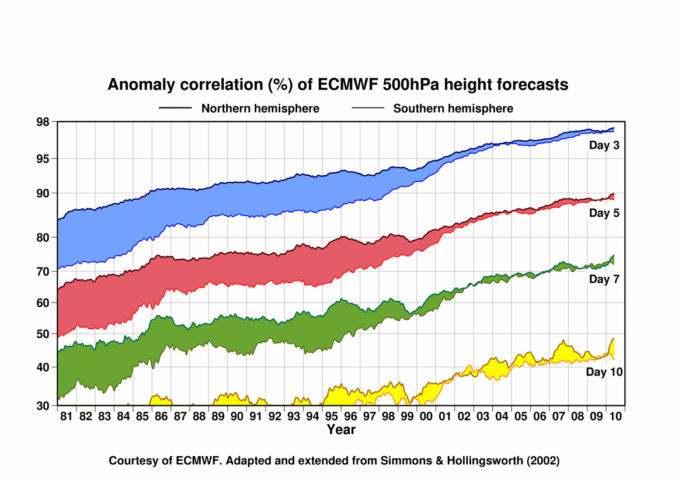

Figure 1: Evolution of ECMWF forecast skill for varying lead times (3 days in blue; 5 days in red; 7 days in green; 10 days in yellow) as measured by 500-hPa height anomaly correlation. Top line corresponds to the Northern Hemisphere; bottom line corresponds to the Southern hemisphere. Large improvements have been made, including a reduction in the gap in accuracy between the hemispheres. SOURCE: courtesy of ECMWF, adapted from Simmons and Holligsworth (2002).

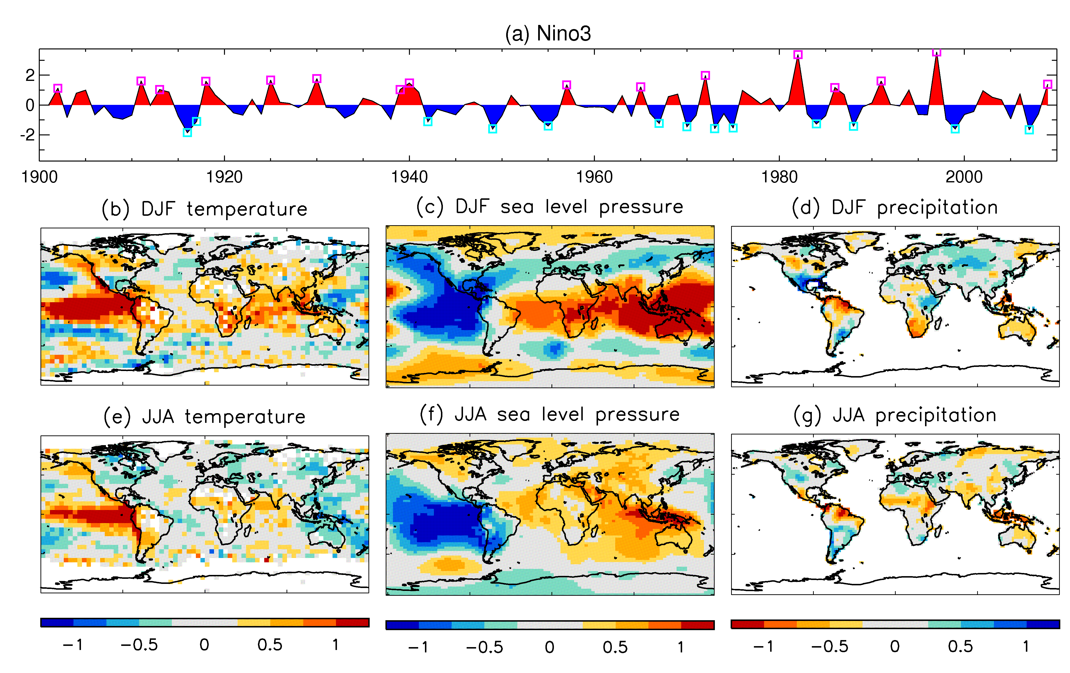
Figure 2: Observed ENSO teleconnections. (a) Time series of SST in the Nino3 region (150-90ºW, 5ºS-5ºN). (b)-(g) Composite differences between positive and negative phases of ENSO, for boreal winter (DJF, b-d) and summer (JJA, e-g). All time series are linearly detrended, and normalised by removing the mean and dividing by the standard deviation. Composite differences are divided by 2 to show the amplitude of the variability. The contour interval is 0.25 (standard deviations), with values greater than 0.2 in magnitude significant at the 95% level based on a one-sided t test. SSTs (a) are taken from HadISST (Rayner et al. 2003), surface temperatures (b,e) are taken from HadCRUT3 (Brohan et al., 2006), sea level pressures (c,f) from HadSLP2 (Allan and Ansell, 2006), and precipitation from GPCC (Rudolf et al., 2005). Positive ENSO years (pink squares in (a)) are 1902, 1911, 1913, 1918, 1925, 1930, 1939, 1940, 1957, 1965, 1972, 1982, 1986, 1991, 1997 and 2009. Negative ENSO years (cyan squares in (a)) are 1916, 1917, 1942, 1949, 1955, 1967, 1970, 1973, 1975, 1984, 1988, 1999 and 2007.

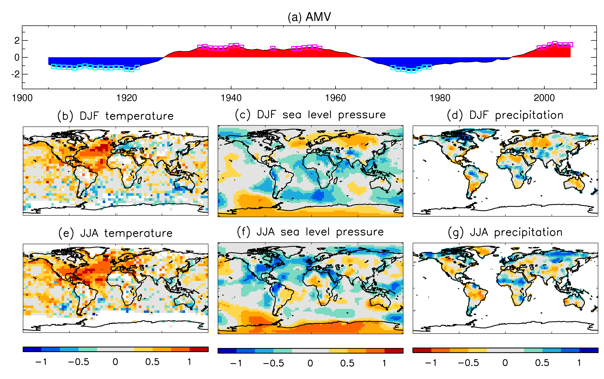
Figure 3: As Fig. 2 but for Atlantic multi-decadal variability (AMV). The AMV index (a) is an index of north Atlantic SST (Enfield et al., 2001) obtained from http://www.esrl.noaa.gov/psd/data/timeseries/AMO/. All time series were smoothed with a 9-year running mean. Positive years are 1934-42, 1948, 1952-57, 1999-2005. Negative years are 1906-22, 1971-78. Assuming 4 degrees of freedom, the contour values ±0.25 and ±0.5 are statistically significant at the 87% and 95% levels, respectively.

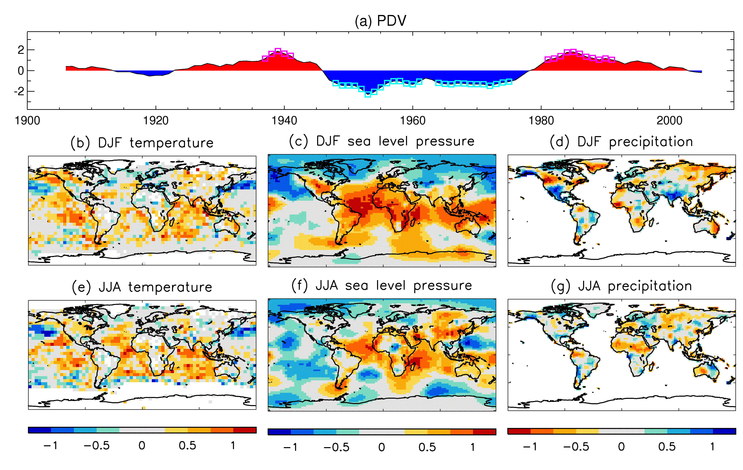
Figure 4: As Fig. 3 but for Pacific decadal variability (PDV). The PDV index (a) is derived from a principal component analysis of SST in the Pacific north of 20ºN (Mantua et al., 1997, Zhang et al., 1997) obtained from http://jisao.washington.edu/pdo/PDO.latest. Positive years are 1937-41, 1981-91. Negative years are 1948-61, 1964-75.

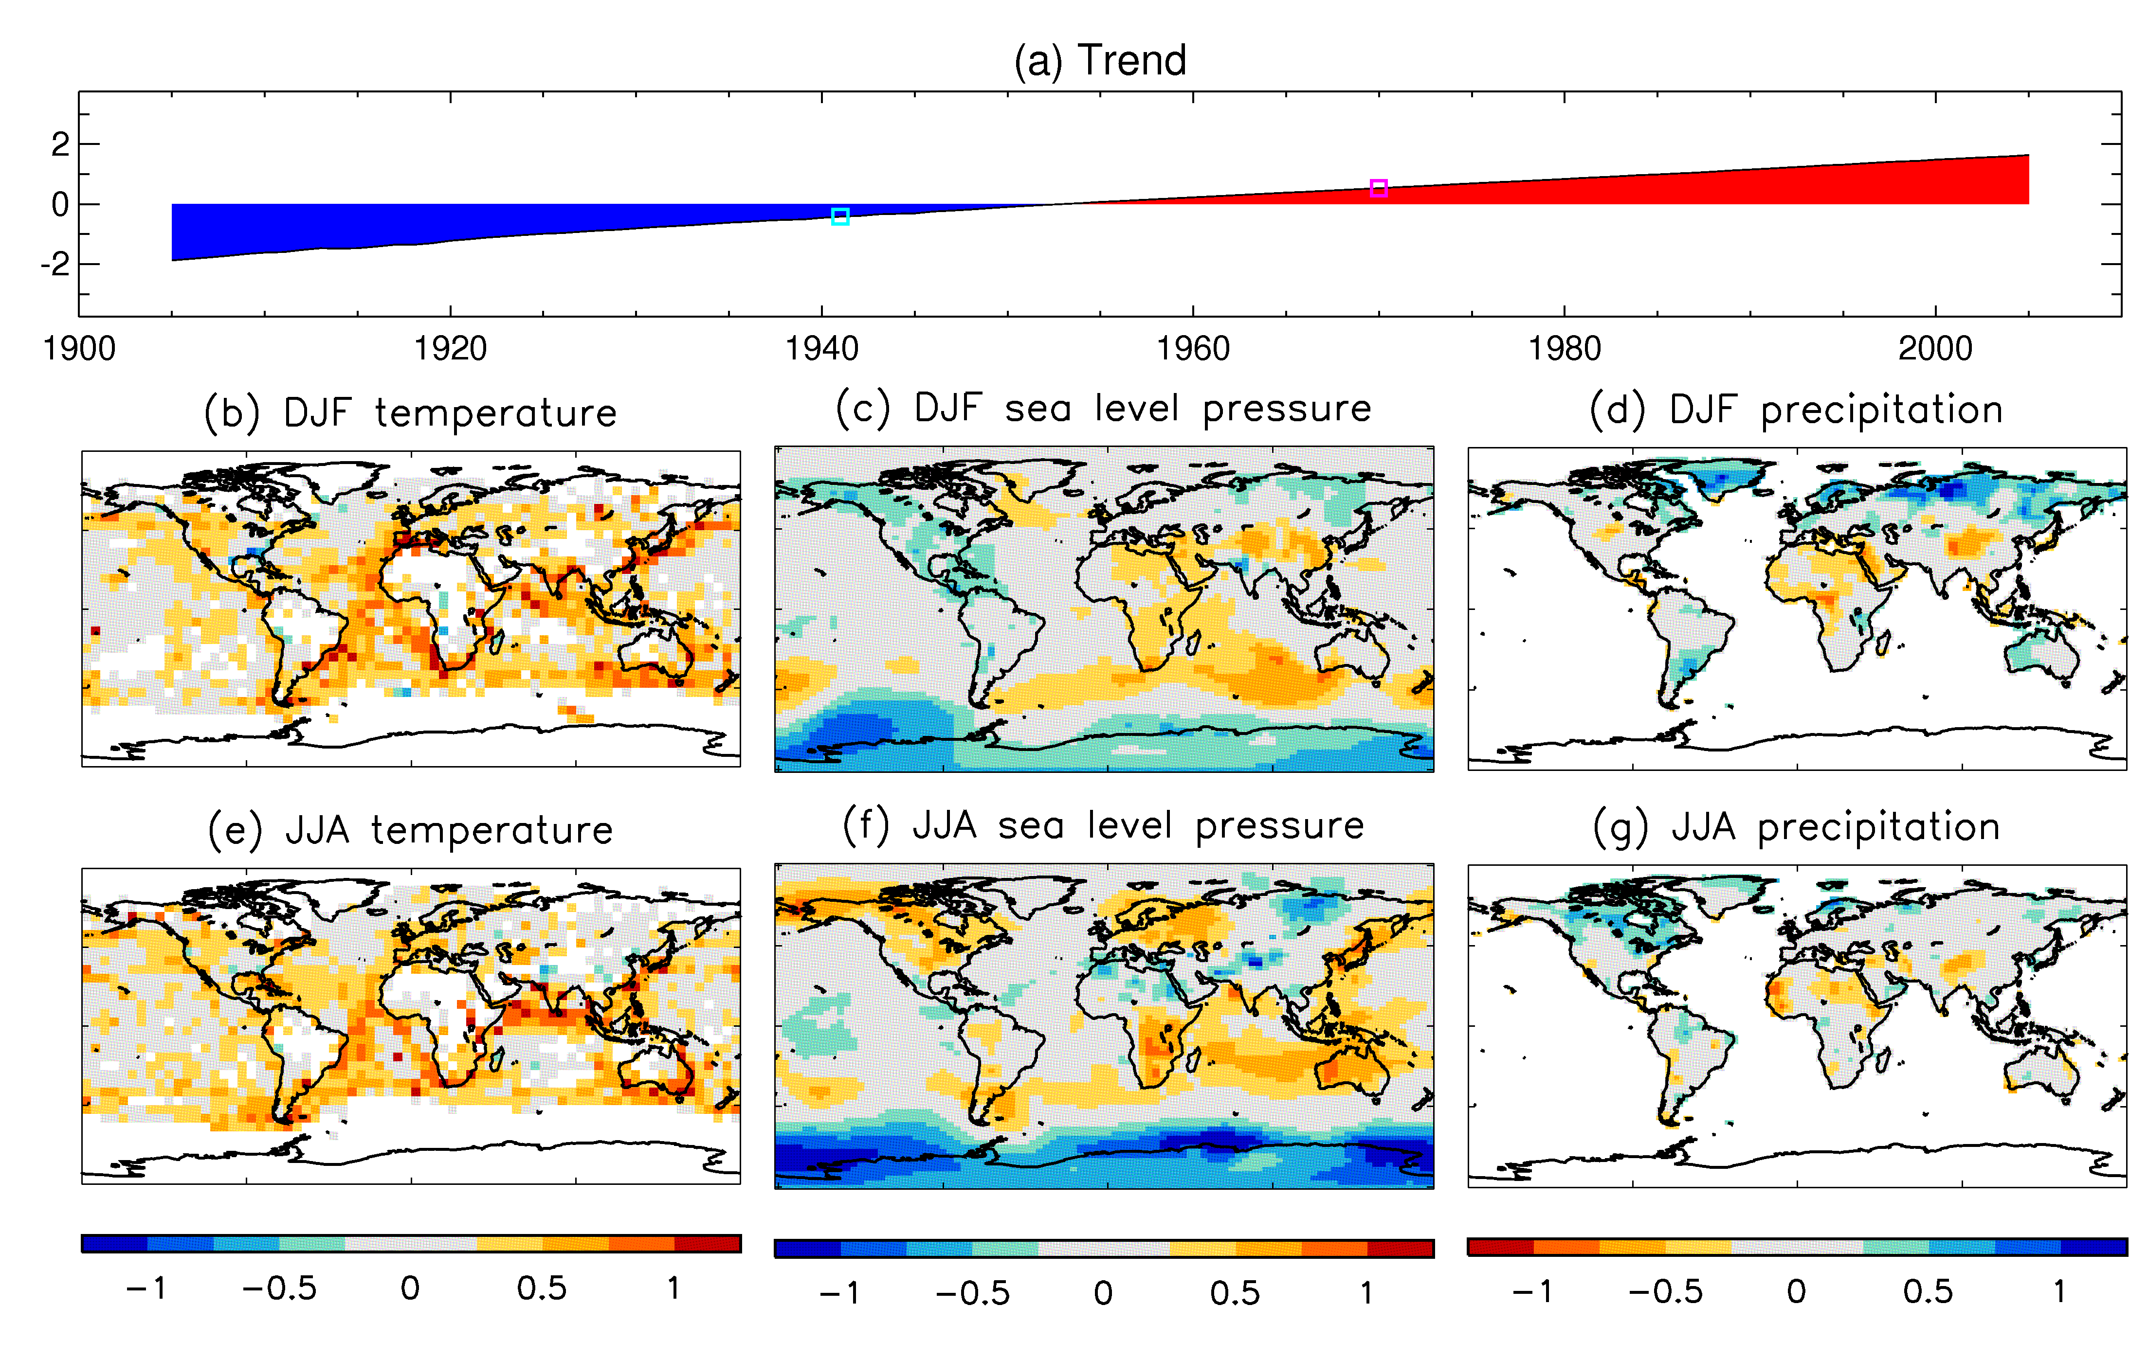
Figure 5: As Fig. 3 but for trends. For comparison with AMV and PDV, which show a transition from neutral to peak conditions over about 15 years, we show 15-year normalised differences.

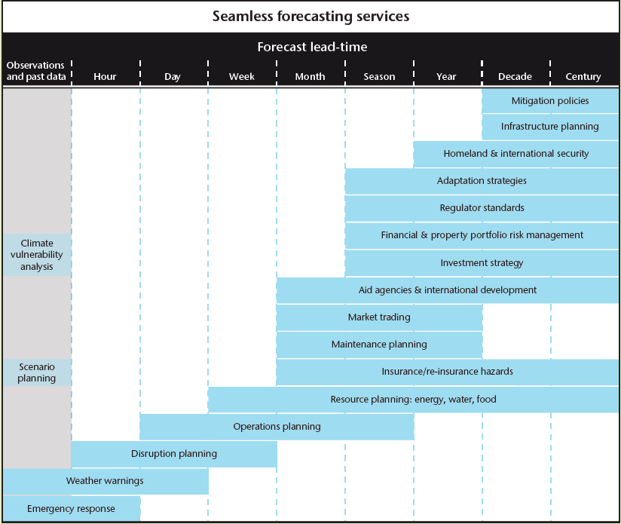

Figure 6: Seamless forecasting services and potential users of monthly to decadal predictions (from Met Office Science Strategy: http://www.metoffice.gov.uk/media/pdf/a/t/Science_strategy-1.pdf).

Arbitrarily small initial condition errors
Here we define the prediction of climate anomalies as the prediction of statistics of weather (i.e., mean temperature or precipitation, variance, probability of extremes such as droughts, floods, hurricanes, high winds …).
In some of the literature a “prediction” corresponds to an initial value problem and the “projection” corresponds to a boundary forced problem. Here we recognize that decadal prediction and even seasonal prediction is a both an initial value and a boundary value problem. Throughout the text we refer to the combined initial value and boundary value problem as prediction problem.

